Week 1 – Types of Energy

Kinetic energy
Moving things have kinetic energy. The heavier a thing is and the faster it moves the more kinetic energy it has. All moving things have kinetic energy, even very large things, like planets, and very small ones, like atoms.
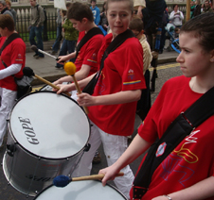

Sound energy
A vibrating drum and a plucked guitar string transfer energy to the air as sound. Kinetic energy from the moving air molecules transfers the sound energy to your eardrum.

Thermal energy
Thermal energy is what we call energy that comes from heat. A cup of hot tea has thermal energy in the form of kinetic energy from its particles. Some of this energy is transferred to the particles in cold milk, which you pour in to make the tea cooler.

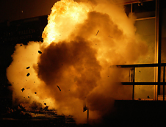

Chemical energy
Some chemical reactions release energy. For example, when an explosive goes off, chemical energy stored in it is transferred to the surroundings as thermal energy, sound energy and kinetic energy.

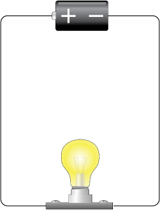

Electrical energy
A battery transfers stored chemical energy as electrical energy in moving charges in wires. For example, electrical energy is transferred to the surroundings by the lamp as light energy and thermal energy.

Bulb and battery
South Bubble mountain, USA

Gravitational potential energy
A rock on a mountain has stored energy because of its position above the ground and the pull of gravity. This energy is called gravitational potential energy. This is the energy it would release if it fell. As the rock falls to the ground, the gravitational potential energy is transferred as kinetic energy.

What are the different type of energy?
Name the energy types, and give 2 different examples of each
Energy Type | Example
K_ _ _ _ _ _
G _ _ _ _ _ _ _ _ _ _ _ _

P_ _ _ _ _ _ _
E_ _ _ _ _ _
C_ _ _ _ _ _
H_ _ _
S _ _ _ _ _
E _ _ _ _ _ _ _ _ _ _

Once completed – Look Cover Write Check
Energy Type | Example
K_ _ _ _ _ _
G _ _ _ _ _ _ _ _ _ _ _ _

P_ _ _ _ _ _ _
E_ _ _ _ _ _
C_ _ _ _ _ _
H_ _ _
S _ _ _ _ _
E _ _ _ _ _ _ _ _ _ _

