Week 7 – Electricity Higher

Measuring current

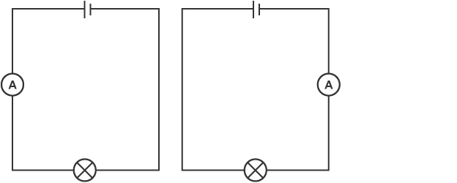
A device called an ammeter is used to measure current. Some types of ammeter have a pointer on a dial, but most have a digital display. To measure the current flowing through a component in a circuit, you must connect the ammeter in series with it.

A circuit with an ammeter connected in two different places, both in series with the cell and lamp

Measuring potential difference
Potential difference is a measure of the difference in energy between two parts of a circuit. The bigger the difference in energy, the bigger the potential difference
Potential difference is measured using a device called a voltmeter. Just like ammeters, some types have a pointer on a dial, but most have a digital display. However, unlike an ammeter, you must connect the voltmeter in parallel to measure the potential difference across a component in a circuit.

When two components are connected in parallel, you cannot follow the circuit through both components from one side to the other without lifting your finger or going back over the path you have already taken.

Exercise 1A

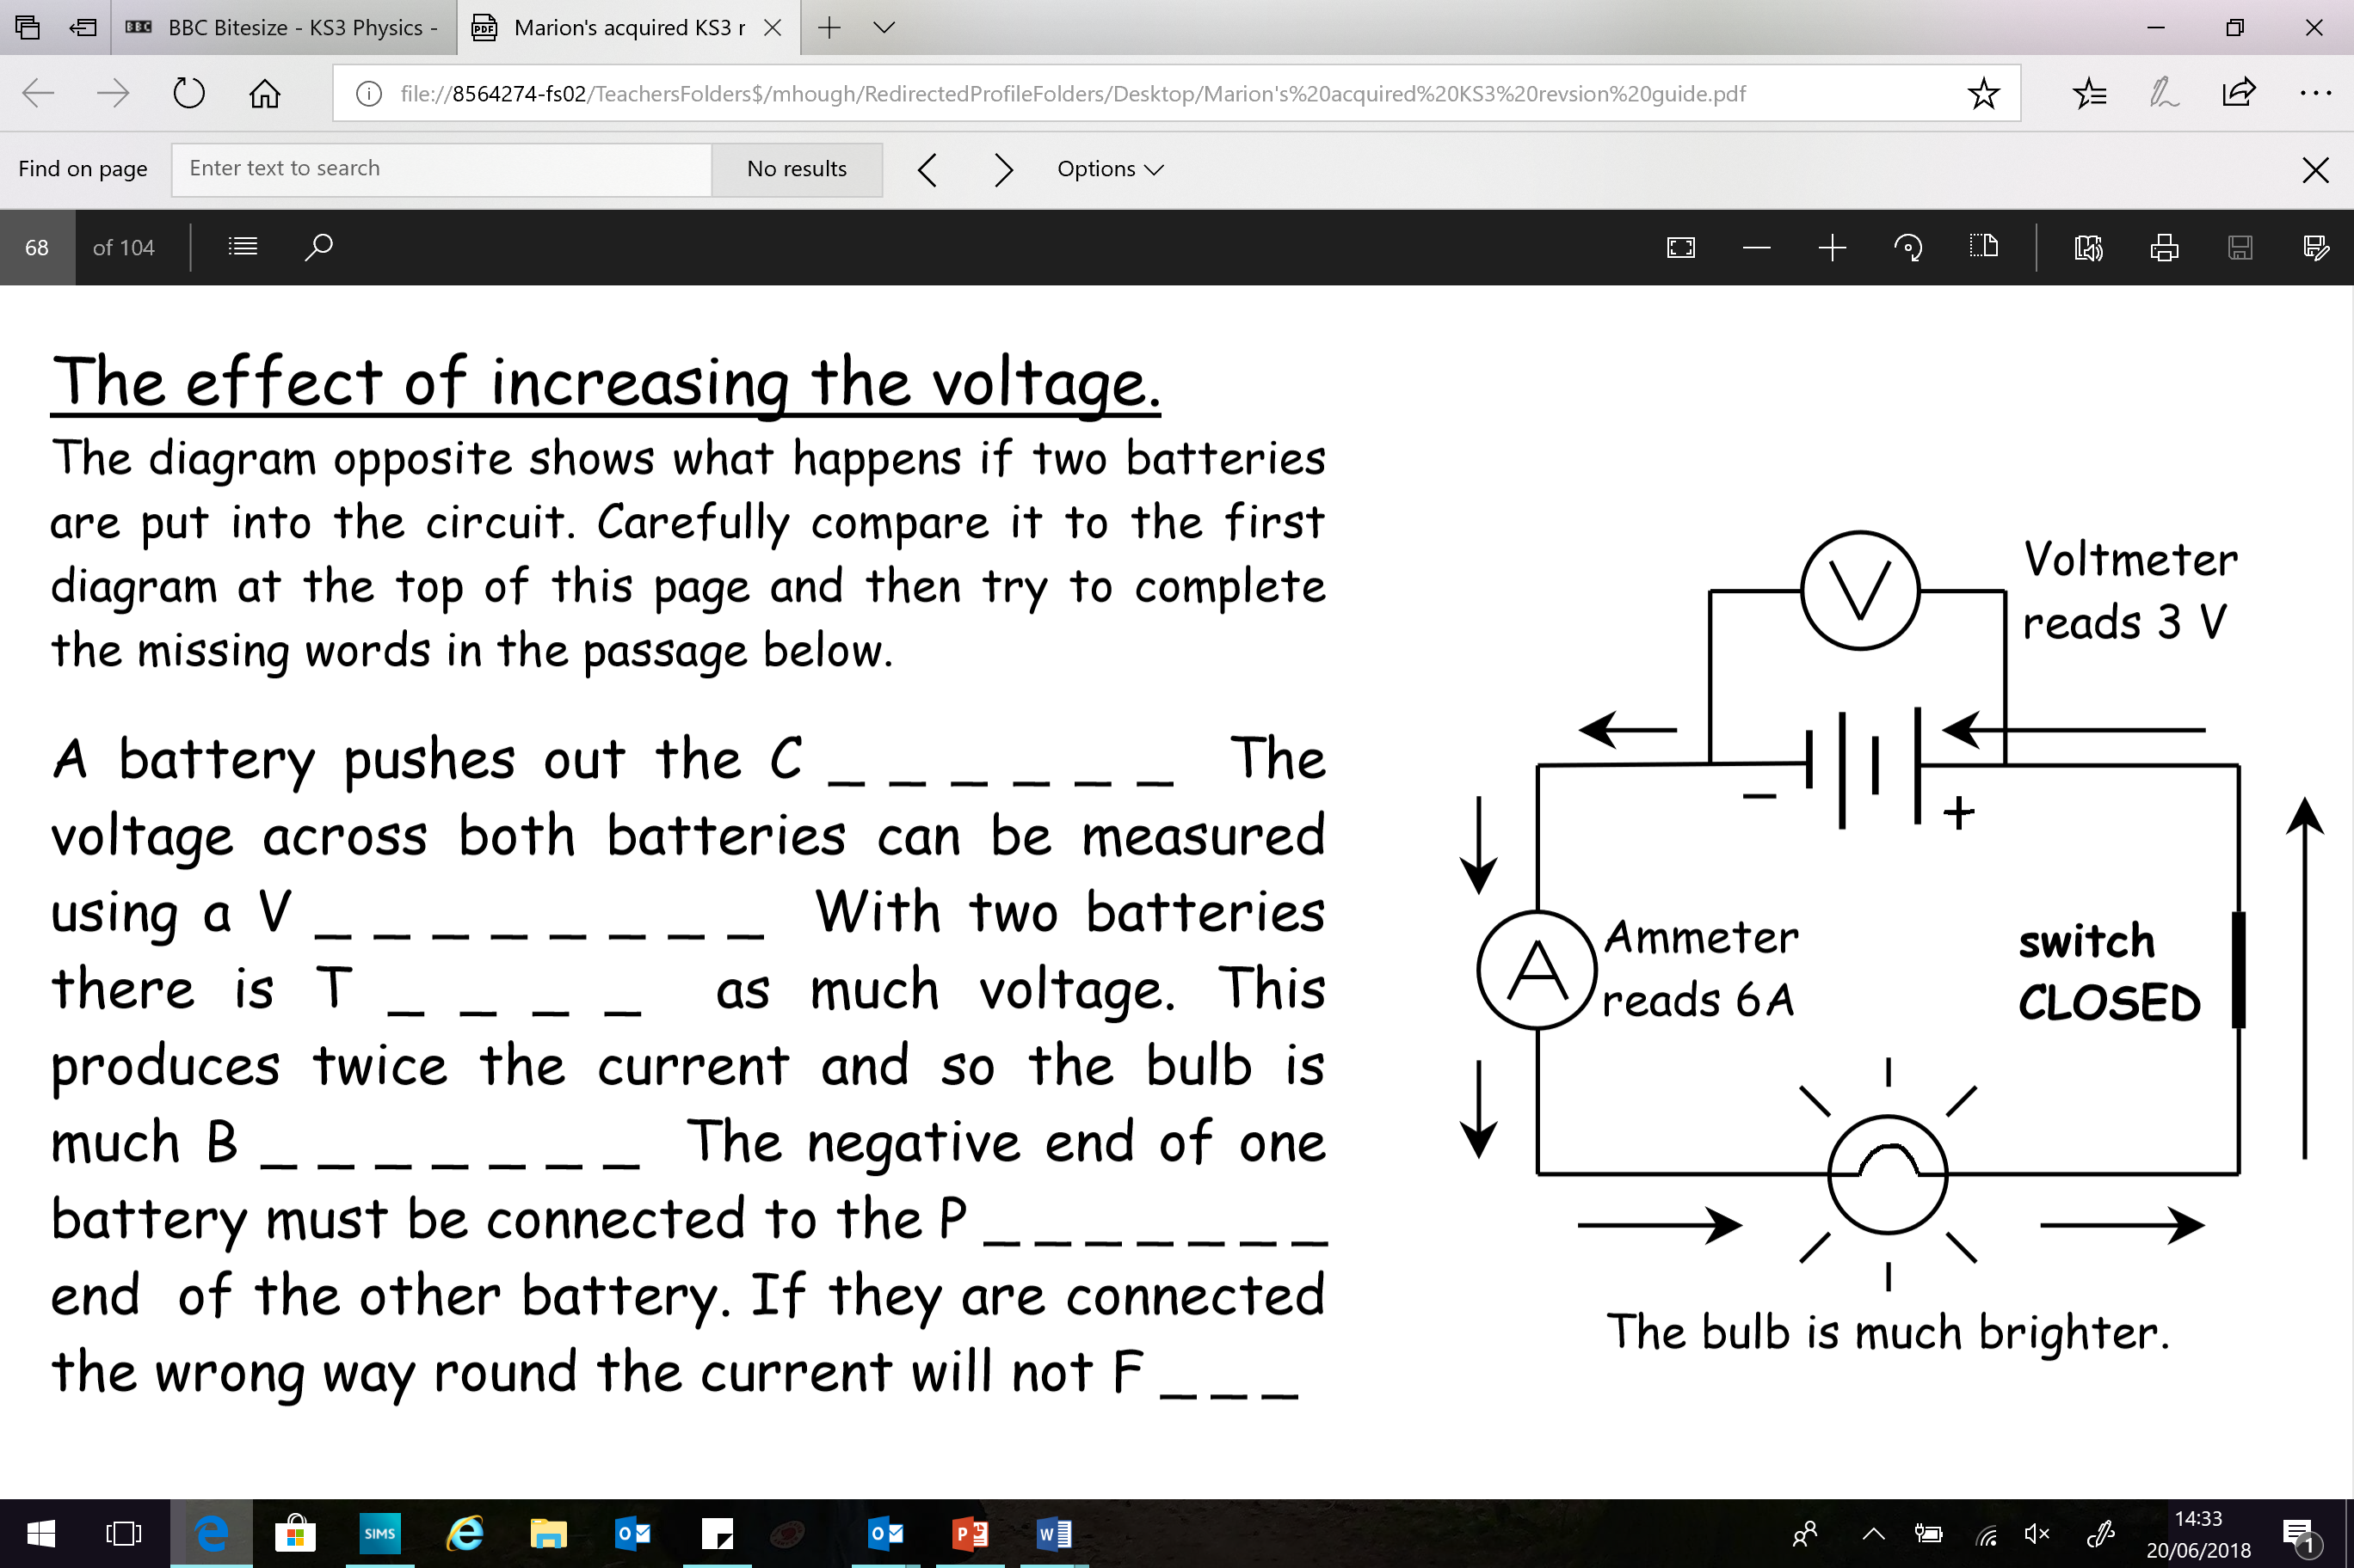

Exercise 1B
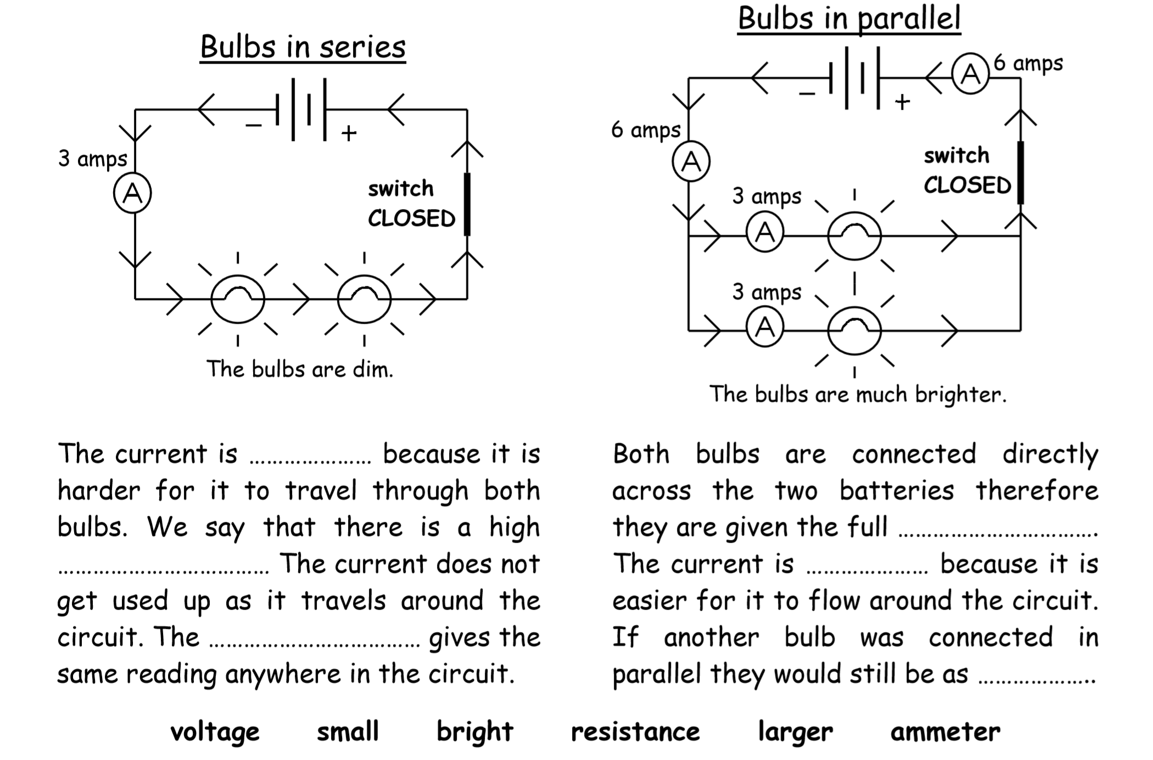

Electric charge
Some particles carry an electric charge. In electric wires these particles are electrons. We get an electric current when these charged particles move from place to place.

Electric current
An electric current is a flow of charge, and in a wire this will be a flow of electrons. We need two things for an electric current to flow:
- something to transfer energy to the electrons, such as a battery or power pack
- a complete path for the electrons to flow through (an electric circuit)
