Y11 Combined Physics 1
PPE 2 - Higher

The topics below will be assessed in your next PPE
Energy
- Changes in energy KE/GPE
- National and global resources
- Power

Electricity
- Resistors including RPA
- Domestic uses and safety
- Energy transfer including use of power formula

Particles
- Temperature change and specific heat capacity

Atomic structure
- Atoms and nuclear radiation
- Radioactive decay

Exam Practice
The following pages contain past exam questions that should attempt.
The grade for each question is indicated by:

Remember: to get Grade 7, 8 or 9 you still have to be able to answer the 4-5 questions!

Use your revision guide to help you answer the questions in this booklet.

The revision guide also has extra questions you can complete.
For each topic, there are questions in the Revision Guide that will help you choose what to revise. The page numbers you need are listed below.
Topic | Questions  Page Title |  | Support  Pages
Kinetic / gravitational potential energy | 178 | Energy stores and systems | 167-168
National and global resources | 178 | Energy resources and trends in their use | 173-177
Power | 190 | Power and the National Grid | 187-189
Resistors | 190 | Circuit basics | 179-185
Domestic electricity | 190 | Electricity in the home | 186
Specific heat capacity | 178 | Specific heat capacity | 169
Atoms and nuclear radiation | 200 | The atomic model | 195
Radioactive decay | 200 | Nuclear decay and half-life | 196-198
Kinetic / Gravitational Potential Energy
Q1.
The diagram below shows a girl skateboarding on a semi-circular ramp.
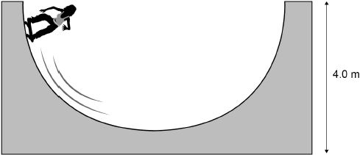
The girl has a mass of 50 kg
(a) Calculate the gravitational potential energy (g.p.e.) of the girl at the top of the ramp.
Use the equation:
g.p.e. = mass × gravitational field strength × height
gravitational field strength = 9.8 N/kg
___________________________________________________________________
___________________________________________________________________
g.p.e. = ________________________ J
(2)
(b) The girl has a speed of 7 m/s at the bottom of the ramp.
Calculate the kinetic energy of the girl at the bottom of the ramp.
Use the equation:
kinetic energy = 0.5 × mass × (speed)²
___________________________________________________________________
___________________________________________________________________
Kinetic energy = ________________________ J
(2)
(c) Not all of the g.p.e. has been transferred to kinetic energy.
Which two statements explain why?
Tick two boxes.

Some energy is wasted.
The mass of the girl is too low.
The ramp is not high enough.
The g.p.e. of the girl is not zero.
The speed of the girl is too great.
(2)
(d) Explain how lubricating the wheels of the skateboard can increase the speed of the girl.
Use ideas about energy in your explanation.
___________________________________________________________________
___________________________________________________________________
___________________________________________________________________
___________________________________________________________________
___________________________________________________________________
___________________________________________________________________
(3)
(Total 9 marks)
Kinetic / Gravitational Potential Energy
Q2.
The miners working in a salt mine use smooth wooden slides to move quickly from one level to another.
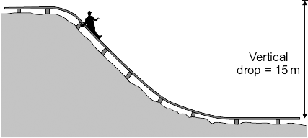
(a) A miner of mass 90 kg travels down the slide.
Calculate the change in gravitational potential energy of the miner when he moves 15 m vertically downwards.

gravitational field strength = 10 N/kg
Show clearly how you work out your answer.
___________________________________________________________________
___________________________________________________________________
Change in gravitational potential energy = _________________________ J
(2)
(b) Calculate the maximum possible speed that the miner could reach at the bottom of the slide.
Show clearly how you work out your answer.
Give your answer to an appropriate number of significant figures.
___________________________________________________________________
___________________________________________________________________
___________________________________________________________________
___________________________________________________________________
Maximum possible speed = _________________________ m/s
(3)
(c) The speed of the miner at the bottom of the slide is much less than the calculated maximum possible speed.
Explain why.
___________________________________________________________________
___________________________________________________________________
___________________________________________________________________
___________________________________________________________________
___________________________________________________________________
___________________________________________________________________
___________________________________________________________________
(3)
(Total 8 marks)
Global and National Resources
Q3.
A small community of people live in an area in the mountains.
The houses are not connected to the National Grid.
The people plan to buy an electricity generating system that uses either the wind or the flowing water in a nearby river.
Figure 1 shows where these people live.
Figure 1
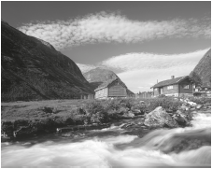
(a) It would not be economical to connect the houses to the National Grid.
Give one reason why.
___________________________________________________________________
___________________________________________________________________
___________________________________________________________________
___________________________________________________________________
(1)
(b) In this question you will be assessed on using good English, organising information clearly and using specialist terms where appropriate.
Information about the two electricity generation systems is given in Figure 2.
Figure 2

The wind turbine costs £50 000 to buy and install.
The hydroelectric generator costs £20 000 to buy and install.
The average power output from the wind turbine is 10 kW.
The hydroelectric generator will produce a constant power output of 8 kW.
Compare the advantages and disadvantages of the two methods of generating electricity.
Use your knowledge of energy sources as well as information from Figure 2.

(6)
(Total 7 marks)
Power
Q4.
A student did an experiment to calculate her power.
The diagram below shows how she obtained the measurements needed.
The student first weighed herself and then ran up a flight of stairs. A second student timed how long it took her to go from the bottom to the top of the stairs. The height of the stairs was also measured.
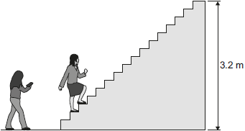
(a) Complete the following sentence.
To run up the stairs the student must do work against
the force of ___________ .
(1)
(b) The student did 2240 J of work going from the bottom of the stairs to the top of the stairs.
The student took 2.8 seconds to run up the stairs.
(i) Calculate the power the student developed when running up the stairs.
______________________________________________________________
______________________________________________________________
Power = ___________ W
(2)
(ii) How much gravitational potential energy did the student gain in going from the bottom to the top of the stairs?
Tick (✔) one box.

much more than 2240 J
2240 J
much less than 2240 J
(1)
(c) Another four students did the same experiment.
The measurements taken and the calculated values for power are given in the table.

Student | Weight in newtons | Time taken in seconds | Power in watts
A | 285 | 3.8 | 240
B | 360 | 2.4 | 480
C | 600 | 3.4 | 560
D | 725 | 4.0 | 580
(i) To make a fair comparison of their powers the students kept one variable in the experiment constant.
What variable did the students keep constant?
______________________________________________________________
(1)
(ii) From the data in the table a student wrote the following conclusion.
'The greater the weight of the student the greater the power developed.'
Suggest why this conclusion may not be true for a larger group of students.
______________________________________________________________
______________________________________________________________
(1)
(Total 6 marks)
Power
Q5.
A student finds some information about energy-saving light bulbs.
(a) A 30W light bulb uses 600J of electrical energy in a certain period of time. In that time, it produces 450 J of light energy. The rest of the energy is wasted.
(i) Calculate the energy wasted by the light bulb in this period of time.
______________________________________________________________
Wasted energy = _________________ J
(1)
(ii) What happens to the energy wasted by the light bulb?
______________________________________________________________
______________________________________________________________
(1)
(iii) Calculate the efficiency of this light bulb.
______________________________________________________________
fficiency = ______________________________
(2)
(iv) Calculate the period of time, in seconds, during which the 600 J is provided to the 30 W light bulb.
______________________________________________________________
Time = _____________ s
(2)
(b) A company that makes light bulbs provides information about some of their products.
The table shows some of this information.

 | Power in watts | Lifetime in hours | Cost of bulb in £
Filament bulb | 60 | 1250 | 2.00
LED bulb | 12 | 50 000 | 16.00
(i) Suggest why it is important to confirm this information independently.
______________________________________________________________
(1)
(ii) A homeowner is thinking about replacing his filament bulbs with LED bulbs.
A 12 W LED bulb gives the same light output as a 60 W filament bulb.
Suggest reasons why the homeowner is likely to choose LED bulbs.
Use the information given in the table.
______________________________________________________________
______________________________________________________________
______________________________________________________________
______________________________________________________________
(2)
(iii) State one factor, other than efficiency, that is important when considering the choice of a bulb for lighting in the home.
______________________________________________________________
______________________________________________________________
(1)
(Total 10 marks)
Resistors
Q6.
(a) Figure 1 shows the inside of a battery pack designed to hold three identical 1.5 V cells.
Figure 1
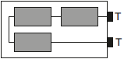
Which one of the arrangements shown in Figure 2 would give a 4.5 V output across the battery pack terminals T?
Figure 2
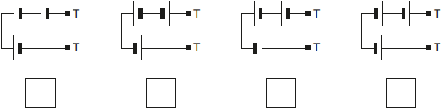
(1)
(b) Figure 3 shows a variable resistor and a fixed value resistor connected in series in a circuit.
Figure 3
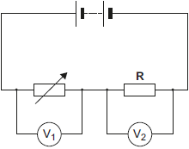
Complete Figure 3 to show how an ammeter would be connected to measure the current through the circuit.
Use the correct circuit symbol for an ammeter.
(1)
(c) The variable resistor can be adjusted to have any value from 200 ohms to 600 ohms.
Figure 4 shows how the reading on voltmeter V₁ and the reading on voltmeter V₂ change as the resistance of the variable resistor changes.
Figure 4
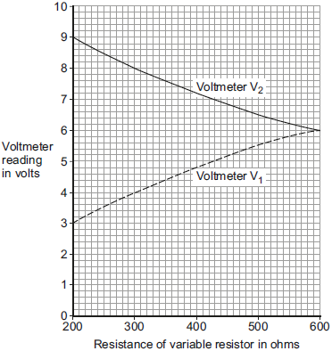
(i) How could the potential difference of the battery be calculated from Figure 4?
Tick (✔) one box.

9 + 3 = 12 V
9 – 3 = 6 V
9 ÷ 3 = 3 V
Give the reason for your answer.
______________________________________________________________
______________________________________________________________
(2)
(ii) Use Figure 4 to determine the resistance of the fixed resistor, R.
Resistance of R = ___________ Ω
Give the reason for your answer.
______________________________________________________________
______________________________________________________________
(2)
(iii) Calculate the current through the circuit when the resistance of the variable resistor equals 200 Ω.
______________________________________________________________
______________________________________________________________
______________________________________________________________
Current = ___________ A
(3)
(Total 9 marks)
Electricity and Power
Q7.
An electric current is a flow of electrical charge through a circuit.
(a) Complete the sentence.
Use a word from the box.

atoms | electrons | ions | molecules
Metals are good conductors of electricity because electrical charge is transferred
by delocalised __________________________
(1)
(b) Draw one line from each symbol to the name of the component.
Standard symbol Name of component
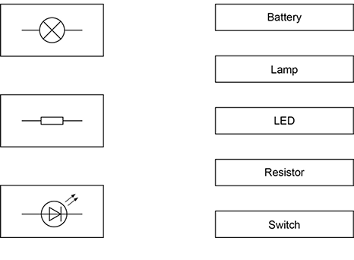
(3)
(c) The table below shows information about some electrical appliances.

Electrical appliance | Power in watts
Hairdryer | 1500
Kettle | 2500
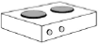  Electric hob | 3000
Television | 360
A student plugs all four of the appliances into one multi-way socket.
The mains electricity is 230 V.
The highest safe current in the socket is 30 A.
Explain why it is not safe to use all four appliances at the same time.
In your answer you should:
• calculate the total power needed
• use the equation
current = power ÷ potential difference
to calculate the total current needed.
___________________________________________________________________
___________________________________________________________________
___________________________________________________________________
___________________________________________________________________
___________________________________________________________________
___________________________________________________________________
___________________________________________________________________
___________________________________________________________________
(4)
(d) The figure below shows how electrical power is transferred from power stations to consumers using the National Grid.
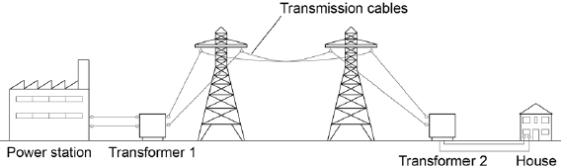
Transformer 1 is a step-up transformer.
Explain why step-up transformers are used in the National Grid.
___________________________________________________________________
___________________________________________________________________
___________________________________________________________________
___________________________________________________________________
___________________________________________________________________
___________________________________________________________________
(3)
(e) What is the purpose of Transformer 2?
___________________________________________________________________
___________________________________________________________________
(1)
(f) In a power station 900 MJ of thermal energy were released by burning natural gas.
Write down the equation that links efficiency, useful input energy transfer and useful output energy transfer.
___________________________________________________________________
(1)
(g) In a power station 900 MJ of thermal energy were released by burning natural gas.
Only 405 MJ was generated.
Calculate the efficiency of this energy transfer.
___________________________________________________________________
___________________________________________________________________
___________________________________________________________________
Efficiency = _________________
(2)
(Total 15 marks)
Energy and Power
Q8.
An energy input of 1.3 × 10¹⁸ J is supplied each year by power stations to the National Grid.
Not all of this energy is supplied to consumers. Some of the energy is wasted in the distribution process.
(a) Write the equation which links efficiency, total input energy transfer and useful output energy transfer.
___________________________________________________________________
___________________________________________________________________
(1)
(b) The energy supplied each year to consumers is 1.2 × 10¹⁸ J
Calculate the efficiency of the distribution process.
___________________________________________________________________
___________________________________________________________________
___________________________________________________________________
___________________________________________________________________
Efficiency = _______________________
(2)
(c) How is electrical power transmitted across the National Grid to make the process as efficient as possible?
Tick one box.

At a high potential difference and a high current
At a high potential difference and a low current
At a low potential difference and a high current
At a low potential difference and a low current
(1)
(d) Write the equation which links energy transferred, power and time.
___________________________________________________________________
___________________________________________________________________
(1)
(e) A wind turbine supplies a power output of 8000 kW for 1200 seconds.
Calculate the energy transferred by the wind turbine in kJ
___________________________________________________________________
___________________________________________________________________
___________________________________________________________________
___________________________________________________________________
___________________________________________________________________
Energy transferred = ___________________________ kJ
(3)
(f) Describe the environmental advantages and disadvantages of using wind turbines to generate electricity in the UK.
___________________________________________________________________
___________________________________________________________________
___________________________________________________________________
___________________________________________________________________
___________________________________________________________________
___________________________________________________________________
___________________________________________________________________
___________________________________________________________________
___________________________________________________________________
___________________________________________________________________
(4)
(Total 12 marks)
Specific Heat Capacity
Q9.
Students investigated the specific heat capacity of different oils.
The diagram shows the equipment used.
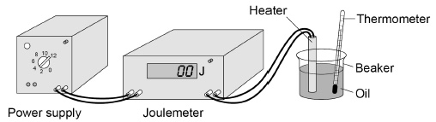
This is the method used.
1. Put 200 g of an oil in a beaker.
2. Record the temperature of the oil.
3. Switch on the heater.
4. After 5 minutes, record the temperature of the oil and the reading on the joulemeter.
5. Repeat steps 1‒4 with different oils.
(a) Give one variable the students controlled in the investigation.
___________________________________________________________________
(1)
The table shows the students’ results for one oil.

Temperature at start in °C | Temperature after 5 minutes in °C
21 | 68
(b) What is the resolution of the thermometer used in the investigation?
Resolution = ____________________ °C
(1)
The students calculated the specific heat capacity of the oil as 2100 J/kg °C
The correct value for the specific heat capacity of the oil is 1630 J/kg °C
(c) Calculate the percentage difference between the two values.
___________________________________________________________________
___________________________________________________________________
Percentage difference = ____________________ %
(2)
(d) Suggest two improvements the students could make to obtain a more accurate value for the specific heat capacity.
1. _________________________________________________________________
___________________________________________________________________
2. _________________________________________________________________
___________________________________________________________________
(2)
(e) A company is considering what metal to use to make saucepans.
They use data about the:
• cost of each metal
• specific heat capacity of each metal.
Suggest two other properties the company needs to consider when deciding which metal to use.
1. _________________________________________________________________
___________________________________________________________________
2. _________________________________________________________________
___________________________________________________________________
(2)
(Total 8 marks)
Atoms and Nuclear Radiaton
Q10.
The figure below is a diagram of an alpha particle and a helium atom.
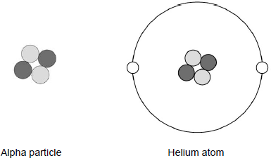
(a) What is the approximate size of a helium atom?
Tick one box.

1 × 10^{–5} m
1 × 10^{–10} m
1 × 10^{–15} m
1 × 10^{–20} m
(1)
(b) A helium atom is much larger than an alpha particle.
Give one other difference between a helium atom and an alpha particle.
___________________________________________________________________
___________________________________________________________________
(1)
(c) What is the atomic number of the helium atom in the figure above?
Tick one box.

2
4
6
8
(1)
(d) What is the charge on the helium atom in the figure above?
Explain your answer.
___________________________________________________________________
___________________________________________________________________
___________________________________________________________________
___________________________________________________________________
___________________________________________________________________
(3)
(e) Helium is a gas that occurs naturally.
There is very little helium on Earth.
Helium has important uses in medicine and is also used to inflate party balloons.
Some scientists believe that helium should not be used to inflate party balloons.
Why?
___________________________________________________________________
___________________________________________________________________
___________________________________________________________________
___________________________________________________________________
(2)
(Total 8 marks)
Radioactive Decay
Q11.
(a) Atoms of the isotope bismuth-212 decay by emitting either an alpha particle or a beta particle.
The equation represents what happens when an atom of bismuth-212 decays by beta emission into an atom of polonium-212.
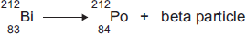
(i) The bismuth atom and the polonium atom have the same mass number (212).
What is the mass number of an atom?
______________________________________________________________
(1)
(ii) Beta decay does not cause the mass number of an atom to change.
Explain why not.
______________________________________________________________
______________________________________________________________
______________________________________________________________
______________________________________________________________
(2)
(b) When an atom of bismuth-212 emits an alpha particle, the atom decays into an atom of thallium.
An alpha particle is the same as a helium nucleus.
The symbol below represents an alpha particle.
(i) The equation below represents the alpha decay of bismuth-212.
Complete the equation by writing the correct number in each of the two boxes.
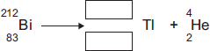
(2)
(ii) It is impossible for the alpha decay of bismuth-212 to produce the same element as the beta decay of bismuth-212.
Explain why.
______________________________________________________________
______________________________________________________________
______________________________________________________________
______________________________________________________________
(2)
(Total 7 marks)

