Year 9
PPE - Foundation

Question | Topics covered
1 | Animal and bacteria cells  Structure of the leaf  Magnification
2 | Osmosis
3 | The digestive system
4 | The heart  Interpreting graphs
5 | Group 1 metals  Balancing equations  Relative mass of compounds
6 | The periodic table  Atomic structure
7 | The periodic table  Atomic structure
Q1.
Figure 1 shows an animal cell and a bacterial cell.
Figure 1
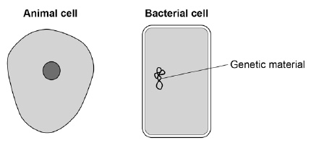
(a) Compare the structure of the cells in Figure 1.
Complete the sentences.
Choose the answers from the box.

cell membrane | cell wall | chloroplast
cytoplasm |  | nucleus
Only the animal cell contains a _________________________________________ .
Only the bacterial cell contains a _______________________________________ .
(2)
Figure 2 shows a section through a leaf.
Figure 2
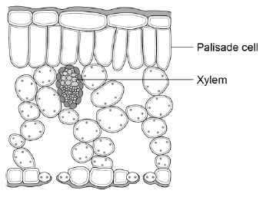
(b) The function of palisade cells is to photosynthesise.
Describe one way palisade cells are adapted to carry out their function.
___________________________________________________________________
___________________________________________________________________
(1)

(c) Complete Table 1 to show whether each structure is a tissue, an organ or an organ system.
Tick one box for each structure.

Table 1
Structure | Tissue | Organ | Organ system
Leaf
Xylem
Roots, stem and leaves
(2)
A student observed palisade cells using a microscope.
The microscope had four objective lenses, each with a different magnification.
(d) Which objective lens should the student use first?
Tick one box.
Give a reason for your answer.

×4 magnification
×10 magnification
×40 magnification
×100 magnification
Reason ____________________________________________________________
___________________________________________________________________
(2)
The student measured the width of 5 different palisade cells at a total magnification of ×400
(e) Eyepiece lenses are usually ×5 or ×10 magnification.
What combination of eyepiece and objective lenses would give a total magnification of ×400?
Eyepiece lens ____________________
Objective lens ____________________
(1)

(f) Table 2 shows the student’s results.

Table 2
Cell | Width of cell image in mm
1 | 12
2 | 13
3 | 16
4 | 10
5 | 11
(f) Calculate the mean width of the palisade cell images.
___________________________________________________________________
___________________________________________________________________
Mean width = ____________________ mm
(1)
(g) Calculate the real width of a palisade cell.
Use the mean width you calculated in part (f).
Use the equation:
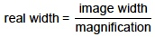
___________________________________________________________________
___________________________________________________________________
Real width = ____________________ mm
(2)
(Total 11 marks)

Q2.
Osmosis is the movement of water through partially permeable cell membranes.
A group of students investigated the effect of temperature on the rate of osmosis in potato cells. The students used five potato chips all cut to the same size.
Figure 1 shows one chip.
Figure 1
This is the method used.
1. Half fill a boiling tube with distilled water.
2. Heat the water to 25 °C
3. Place one potato chip in the boiling tube.
4. Keep the boiling tube and potato chip at 25 °C for 30 minutes.
5. Repeat steps 1−4 at four other temperatures.
(a) All of the potato chips gained water by osmosis.
Explain how the students would find out the rate of water uptake by osmosis in each potato chip.
___________________________________________________________________
___________________________________________________________________
___________________________________________________________________
___________________________________________________________________
___________________________________________________________________
___________________________________________________________________
(3)
(b) One of the students used a knife to cut the potato chips.
Suggest how the student could improve the method of cutting the potato chips to make sure they are all the same size.
___________________________________________________________________
___________________________________________________________________
(1)

(c) Another student cut their potato chips as shown in Figure 2.
Figure 2
Suggest how the rate of water uptake by osmosis in this investigation was different from the investigation with the chips shown in Figure 2.
Give a reason for your answer.
___________________________________________________________________
___________________________________________________________________
___________________________________________________________________
___________________________________________________________________
(2)
(d) The students carried out the experiment at 25 °C, 30 °C, 35 °C, 40 °C and 45 °C
Predict what you would expect the results to show as the temperature increases.
Give a reason for your answer.
Prediction __________________________________________________________
___________________________________________________________________
Reason ____________________________________________________________
___________________________________________________________________
(2)
(Total 8 marks)

Q3.
The digestive system breaks down food into small molecules.
The small molecules can be absorbed into the blood.
The diagram below shows the human digestive system.
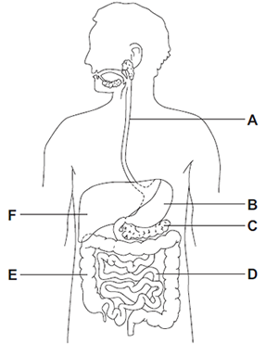
(a) (i) Which letter, A, B, C, D, E or F, shows each of the following organs?

Write one letter in each box.
large intestine
small intestine
stomach
(3)

(ii) Different organs in the digestive system have different functions.
Draw one line from each function to the organ with that function.
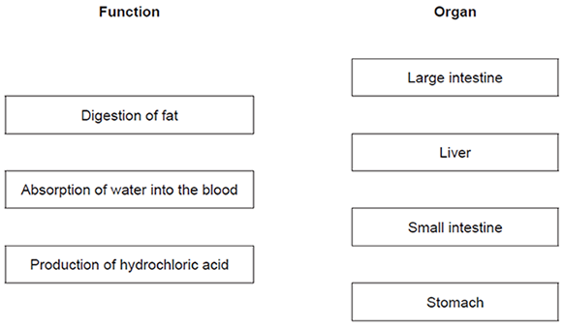
(3)
(b) Glucose is absorbed into the blood in the small intestine.
Most of the glucose is absorbed by diffusion.
How does the glucose concentration in the blood compare to the glucose concentration in the small intestine?

Tick (✔) one box.
The concentration in the blood is higher.
The concentration in the blood is lower.
The concentration in the blood is the same.
(1)
(Total 7 marks)

Q4.
Exercise can improve health.
A student measured her breathing rate at rest, when walking and when jogging.
Figure 1 shows her results.
Figure 1
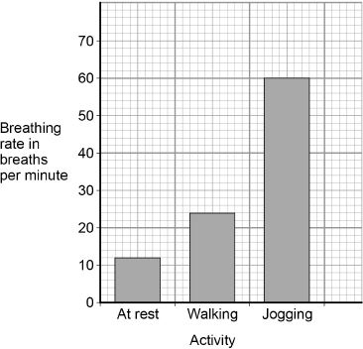
(a) Compare the breathing rates when doing the three different activities.
Use values from Figure 1 in your answer.
___________________________________________________________________
___________________________________________________________________
___________________________________________________________________
___________________________________________________________________
___________________________________________________________________
___________________________________________________________________
(3)
(b) Explain why the breathing rate changes when doing different activities.
___________________________________________________________________
___________________________________________________________________
___________________________________________________________________
___________________________________________________________________
___________________________________________________________________
___________________________________________________________________
(3)
Figure 2 shows the heart in the circulatory system.
Figure 2
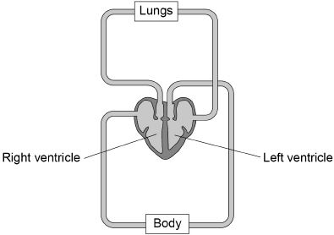
(c) The heart is a double pump.
Describe what this means.
Use Figure 2 to help you.
___________________________________________________________________
___________________________________________________________________
___________________________________________________________________
___________________________________________________________________
(2)
(d) The wall of the left ventricle is much thicker than the wall of the right ventricle.
Suggest one reason for this.
___________________________________________________________________
___________________________________________________________________
___________________________________________________________________
(1)
(e) People are encouraged to exercise after recovering from a heart attack.
Suggest one reason why.
___________________________________________________________________
___________________________________________________________________
(1)
(Total 10 marks)

Q5.

This question is about Group 1 metals.
The graph below shows the melting points of Group 1 metals plotted against their atomic number.
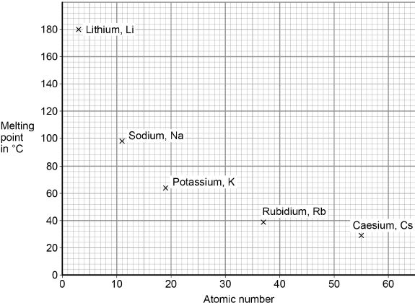
(a) Describe the trend shown by the melting points of Group 1 metals as the atomic number increases.
___________________________________________________________________
___________________________________________________________________
(1)

(b) Determine the atomic number and melting point of caesium.
Use the graph above.
Atomic number of caesium = __________________
Melting point of caesium = _______________ °C
(1)
Lithium is a Group 1 metal.
(c) A lithium atom can be shown as 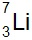
How many electrons does the outer shell of a lithium atom contain?
Tick one box.

1
3
4
7
(1)
(d) Lithium reacts with oxygen to produce lithium oxide.
Draw one line from each substance to the correct description of the substance.

Substance |  | Description
 |  | compound
Lithium oxide |  | element
 |  | metal
Oxygen |  | mixture
 |  | polymer
(2)

(e) Balance the equation for the reaction of lithium with oxygen.
(1)
(f) What type of bonding is present in lithium oxide?
Tick one box.

Covalent
Ionic
Metallic
(1)
(g) Calculate the relative formula mass (M_{r}) of lithium oxide (Li₂O).
Relative atomic masses (A_{r}): Li = 7 O = 16
___________________________________________________________________
___________________________________________________________________
___________________________________________________________________
Relative formula mass = _________________
(2)
(Total 9 marks)

Q6.
This question is about the periodic table.
In 1864 John Newlands suggested an arrangement of elements.
Figure 1 shows the arrangement Newlands suggested.
Figure 1
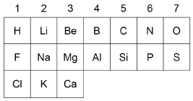
(a) Give two differences between column 1 in Figure 1 and Group 1 in the modern periodic table.
Use the periodic table to help you.
1. _________________________________________________________________
2. _________________________________________________________________
(2)
(b) In 1869 Mendeleev produced his periodic table.
Complete the sentence.
Choose the answer from the box.

insoluble | magnetic | undiscovered | unreactive
Mendeleev left gaps in his periodic table for elements that were
_________________________________________ .
(1)
(c) How are the elements ordered in the modern periodic table?
Tick one box.

Atomic mass
Atomic number
Melting point
Reactivity
(1)
Figure 2 shows part of the modern periodic table.
Figure 2
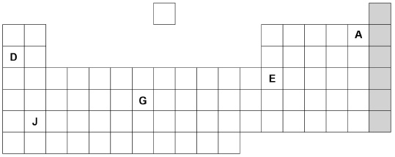
(d) Complete the sentences about the elements in Figure 2.
Choose the answers from the box.

A | D | E | G | J
Sodium is an alkali metal and is represented by the letter ____________________.
An element in group 3 is represented by the letter ____________________.
A gaseous non-metal element is represented by the letter ____________________.
(3)
(e) Figure 3 shows the electronic structure of an atom.
Figure 3
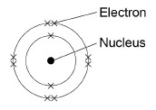
This element is in the shaded group on Figure 2.
Why is this element unreactive?
___________________________________________________________________
___________________________________________________________________
(1)
(f) Name the group of elements in the shaded column on Figure 2.
___________________________________________________________________
(1)
(Total 9 marks)

Q7.
John Newlands arranged the known elements into a table in order of atomic weight.
Figure 1 shows part of Newlands’ table.
Figure 1

Group | 1 | 2 | 3 | 4 | 5 | 6 | 7
 | H | Li | Be | B | C | N | O
 | F | Na | Mg | Al | Si | P | S
 | Cl | K | Ca
(a) What are the names of the elements in Group 5 of Newlands’ table?
Tick one box.

Calcium and sulfur
Carbon and silicon
Chlorine and silver
Chromium and tin
(1)
(b) In what order is the modern periodic table arranged?
Tick one box.

Atomic mass
Atomic number
Atomic size
Atomic weight
(1)

(c) Give two differences between Group 1 of Newlands’ table and Group 1 of the periodic table.
___________________________________________________________________
___________________________________________________________________
___________________________________________________________________
___________________________________________________________________
(2)
(d) In 1864, atoms were thought to be particles that could not be divided up into smaller particles.
By 1898, the electron had been discovered and the plum pudding model of an atom was proposed.
Figure 2 shows the plum pudding model of an atom of carbon and the nuclear model of an atom of carbon.
Figure 2
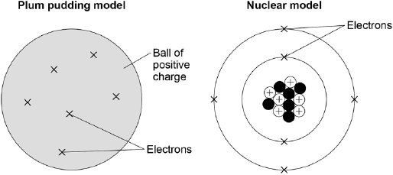
Compare the position of the subatomic particles in the plum pudding model with the nuclear model.
___________________________________________________________________
___________________________________________________________________
___________________________________________________________________
___________________________________________________________________
___________________________________________________________________
___________________________________________________________________
___________________________________________________________________
___________________________________________________________________
(4)

(e) Models are used to show the differences between elements, compounds and mixtures.
Which circle shows a model of a mixture?
Tick one box.
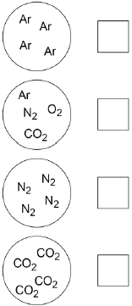
(1)
(f) Figure 3 shows a model of carbon dioxide.
Figure 3
What does each line between the atoms in Figure 3 represent?
Tick one box.

Covalent bond
Intermolecular force
Ionic bond
Metallic bond
(1)
(Total 10 marks)

