Y11 Biology 1
PPE 2 – Higher
For each topic, complete the questions that are in the Revision Guide.
The page numbers you need are listed below.
Topic | Questions  Page Title |  | Support  Pages
RPA – culturing microorganisms | 26 | Culturing Microorganisms | 17-18
Cell division – cell cycle | 26 | Differentiation and division | 14-16
RPA – Enzymes | 45 | The Role of Enzymes | 28-32
Heart and blood vessels / blood components | 45 | The Lungs and Circulatory System | 33-36
Cancer | 45 | Diseases and Risk Factors | 37-41
Plant tissue | 45 | Plant Cell Organisation | 42-44
Viral diseases | 56 | Types of Disease | 46-48
Vaccination | 56 | Fighting Disease | 49-52
Producing monoclonal antibodies | 56 | Antibodies | 53-54
Diagnosis and identification of plant diseases | 56 | Plant Diseases | 55
Uses of glucose |  |  | 67-63
Respiration | 64 | Respiration and Metabolism | 61-63
Exam Practice
The following pages contain past exam questions that should attempt.
The grade for each question is indicated by:

Remember: to get Grade 7, 8 or 9 you still have to be able to answer the 4-5 questions!

RPA – Culturing micro-organisms
Q1. (a) A student tried to grow some bacteria in the laboratory. The diagram shows some of the apparatus used.
Week 1: Cell biology

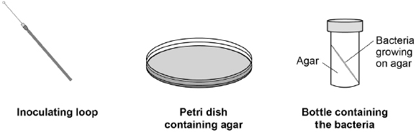
This is the method used.
1. Remove the lid of the Petri dish.
2. Remove the lid of the bottle containing the bacteria.
3. Use the inoculating loop to remove some of the bacteria from the bottle.
4. Spread the bacteria over the agar using the inoculating loop.
5. Put the lid back on the Petri dish.
6. Put the Petri dish into an incubator at 25 °C for 24 hours.
Steps 1−5 could cause the sample of the bacteria on the petri dish to be contaminated.
Give three improvements to the method to prevent contamination.
1. _________________________________________________________________
___________________________________________________________________
2. _________________________________________________________________
___________________________________________________________________
3. _________________________________________________________________
___________________________________________________________________
(3)
(b) Why did the student grow the bacteria at 25 °C rather than at 40 °C?
Tick one box.

So the bacteria grew more quickly
So the bacteria grew more slowly
To prevent the growth of a harmful pathogen
To save money
(1)
(c) After the culture had been prepared, the student added one drop of five disinfectants, A, B, C, D and E, onto the culture.
The diagram shows the appearance of the Petri dish 3 days later.
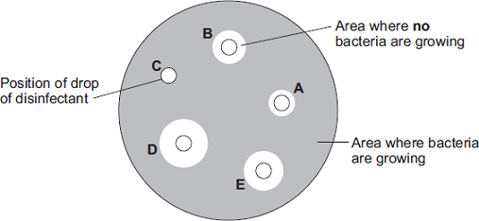
(i) There are areas on the agar jelly where no bacteria are growing.
Why?
______________________________________________________________
______________________________________________________________
(1)
(ii) The student concluded that disinfectant D would be the best for using around the home.
Give one reason why the student might be correct.
______________________________________________________________
______________________________________________________________
______________________________________________________________
Give one reason why the student might not be correct.
______________________________________________________________
______________________________________________________________
______________________________________________________________
(2)
(Total 7 marks)

Cell division – cell cycle
Q2. This question is about the cell cycle.
(a) Chromosomes are copied during the cell cycle.
Where are chromosomes found?
Tick one box.

Cytoplasm
Nucleus
Ribosomes
Vacuole
(1)
(b) What is the name of a section of a chromosome that controls a characteristic?
___________________________________________________________________
(1)
Figure 1 shows information about the cell cycle.
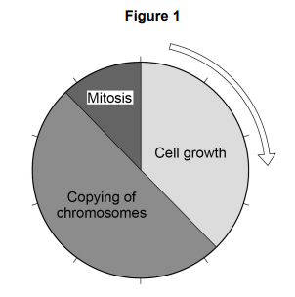
(c) Which stage of the cell cycle in Figure 1 takes the most time?
Tick one box.

Cell growth
Copying of chromosomes
Mitosis
(1)
(d) During mitosis cells need extra energy.
Which cell structures provide most of this energy?
Tick one box.

Chromosomes
Cytoplasm
Mitochondria
Ribosomes
(1)
(e) The cell cycle in Figure 1 takes two hours in total.
The cell growth stage takes 45 minutes.
Calculate the time taken for mitosis.
___________________________________________________________________
___________________________________________________________________
___________________________________________________________________
___________________________________________________________________
Time = ____________________ minutes
(2)
Figure 2 shows some cells in different stages of the cell cycle.
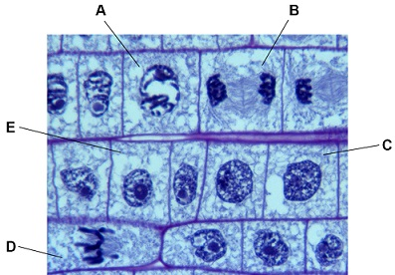

(f) Which cell is not dividing by mitosis
Tick one box.
(1)
(g) Cell E in Figure 2 contains 8 chromosomes.
Cell E divides by mitosis.
How many chromosomes will each new cell contain?
Tick one box.

2
4
8
16
(1)
(h) Why is mitosis important in living organisms?
Tick one box.

To produce gametes
To produce variation
To release energy
To repair tissues
(1)
(Total 9 marks)

RPA – Enzymes
Q3. Amylase is an enzyme found in the human body.
Week 2: Organisation
Amylase breaks down starch into sugars.
(a) Where is amylase produced in the human body?
Tick one box.

Liver and pancreas
Liver and stomach
Salivary glands and pancreas
Salivary glands and stomach
(1)
(b) Enzymes speed up chemical reactions.
Explain how amylase breaks down starch.
___________________________________________________________________
___________________________________________________________________
___________________________________________________________________
___________________________________________________________________
___________________________________________________________________
___________________________________________________________________
(3)
(c) One sugar in the body is glucose.
Glucose is used for respiration.
Give one other use for glucose in the body.
___________________________________________________________________
(1)

(d) A student investigated the effect of temperature on the activity of human amylase.
This is the method used.
1. Put 2 cm³ of 1% starch solution into a boiling tube.
2. Put 2 cm³ of amylase solution into a second boiling tube.
3. Put both boiling tubes into a water bath at 20 °C.
4. After 5 minutes, mix the amylase and the starch together in one boiling tube.
5. After 30 seconds, add a drop of the starch and amylase mixture to a drop of iodine solution in one well of a spotting tile.
6. Repeat step 5 until the iodine solution no longer changes colour.
7. Repeat steps 1 – 6 at 40 °C and at 60 °C and at 80 °C
Why did the student leave the starch and amylase solutions in the water bath for 5 minutes in step 3?
___________________________________________________________________
___________________________________________________________________
(1)
(e) The temperature of the human body is 37 °C
The diagram below shows the results of the investigation at 20 °C and at 80 °C
Complete the diagram to show the results you would expect at 40 °C and at 60 °C
You should write a tick or a cross in each well of the spotting tile.
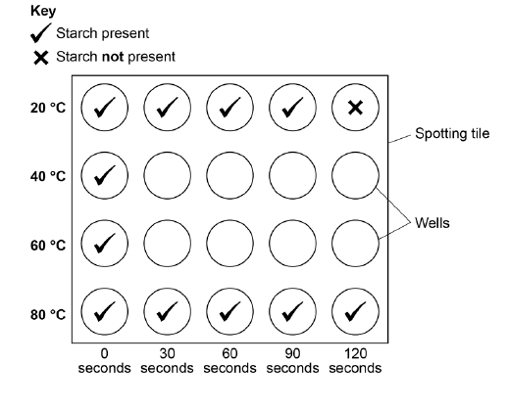
(2)
(f) There are different ways to investigate the breakdown of starch by amylase.
One other method is to measure the concentration of starch present in the solution every 30 seconds.
Why is this method better than the method the student used?
___________________________________________________________________
___________________________________________________________________
___________________________________________________________________
___________________________________________________________________
(2)
A colorimeter can be used to measure the concentration of starch present in the solution every 30 seconds.
A colorimeter measures the amount of light that cannot pass through a solution.
This is known as absorbance.
Below shows a graph of absorbance against concentration of starch.
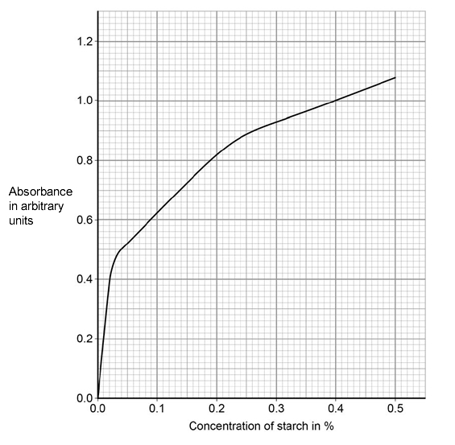
(g) The absorbance of the solution at 40 °C was 0.56 arbitrary units after 30 seconds.
What was the concentration of starch in this solution?
___________________________________________________________________
Concentration of starch = ____________________ %
(1)
(h) The concentration of starch in the solution at 20 °C after 1 minute is different from the concentration at 40 °C after 1 minute.
Explain why.
___________________________________________________________________
___________________________________________________________________
___________________________________________________________________
___________________________________________________________________
(2)
(i) Predict the absorbance for the solution at 80 °C after 30 seconds.
Give a reason for your answer.
Absorbance = ______________________ arbitrary units
Reason ____________________________________________________________
___________________________________________________________________
___________________________________________________________________
___________________________________________________________________
(3)
(Total 16 marks)
Heart and blood vessels / blood components
Q4. Diagram 1 shows a section through the heart.
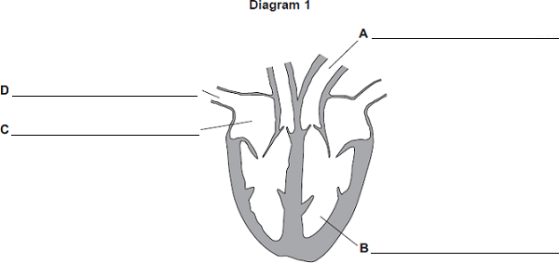
(a) On the diagram, name the parts labelled A, B, C and D.
(4)
(b) Diagram 2 shows the blood vessels that supply the heart muscle.
Part of one of the blood vessels has become narrower.
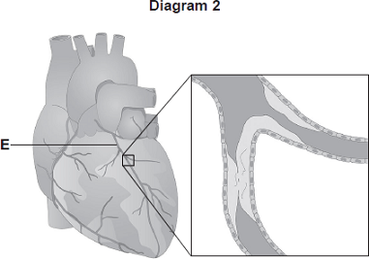
(i) Name blood vessel E.
______________________________________________________________
(1)
(c) Diagram 3 shows part of the blood supply in the lungs.
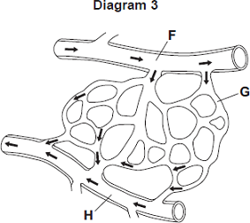
(i) Name the types of blood vessel labelled F, G and H.
F ____________________________________________________________
G ____________________________________________________________
H ____________________________________________________________
(3)
(ii) Give one way in which the composition of the blood in vessel F is different from the composition of the blood in vessel H.
______________________________________________________________
______________________________________________________________
(1)
(d) Urea is transported in the blood plasma.
Name two other substances transported in the blood plasma.
1. _________________________________________________________________
2. _________________________________________________________________
(2)
Figure 1 shows the three types of blood vessel.
Figure 1
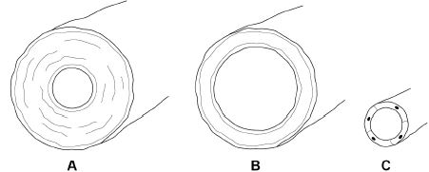
(e) Which type of blood vessel carries blood into the right atrium?
Tick one box.
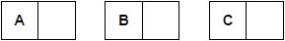
(1)
(f) Compare the structure of an artery with the structure of a vein.
___________________________________________________________________
___________________________________________________________________
___________________________________________________________________
___________________________________________________________________
___________________________________________________________________
___________________________________________________________________
___________________________________________________________________
(3)
(g) A patient may be fitted with an artificial pacemaker.
What condition may be treated using an artificial pacemaker?
___________________________________________________________________
___________________________________________________________________
(1)
(Total 16 marks)
Cancer
Week 3: Organisation
Q5. The number of people in the UK with tumours is increasing.
(a) (i) Describe how tumours form.
______________________________________________________________
______________________________________________________________
(1)
(ii) Tumours can be malignant or benign.
What is the difference between a malignant tumour and a benign tumour?
______________________________________________________________
______________________________________________________________
(1)
(b) Describe how some tumours may spread to other parts of the body.
___________________________________________________________________
___________________________________________________________________
(1)
(c) People from Northern Europe have fair skin and many people have malignant melanoma skin cancer.
The graph shows how the number of people in the UK with malignant melanoma changed between 1985 and 2008.
The bars on the graph show the number of people in the UK who travelled abroad and the number who took cheap holidays in the sun in 1985 and 2005.
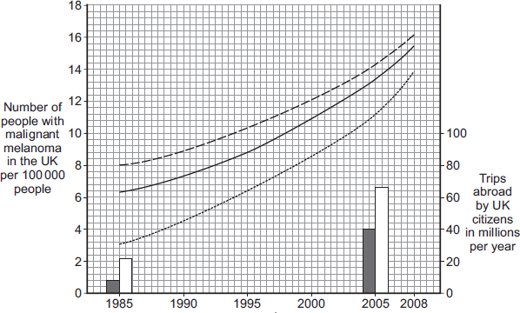
Years

Key
Mean for all areas  Mean for people from rich areas  Mean for people from poor areas | Total number of trips abroad  Number of cheap holidays in  the sun
(i) Describe the trends in the number of people with malignant melanoma skin cancer between 1985 and 2008.
______________________________________________________________
______________________________________________________________
______________________________________________________________
______________________________________________________________
______________________________________________________________
______________________________________________________________
(3)
(ii) Use the data about the number of trips abroad to suggest an explanation for the trends you have described in part (c)(i).
______________________________________________________________
______________________________________________________________
______________________________________________________________
______________________________________________________________
(2)
(d) Describe how stomach cancer can spread to the liver.
___________________________________________________________________
___________________________________________________________________
___________________________________________________________________
___________________________________________________________________
___________________________________________________________________
___________________________________________________________________
(3)
(Total 12 marks)

Plant tissue
Q6. The diagram shows a section through a plant leaf.
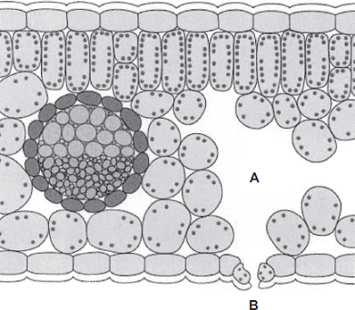
(a) Use words from the box to name two tissues in the leaf that transport substances around the plant.

epidermis | mesophyll | phloem | xylem

______________________________ and ______________________________
(1)
(b) Gases diffuse between the leaf and the surrounding air.
(i) What is diffusion?
______________________________________________________________
______________________________________________________________
______________________________________________________________
______________________________________________________________
(2)
(ii) Name one gas that will diffuse from point A to point B on the diagram on a sunny day.
______________________________________________________________
(1)

(c) In this question you will be assessed on using good English, organising information clearly and using specialist terms where appropriate.
Plants transport many substances between their leaves and roots. The diagram below shows the direction of movement of substances through a plant.
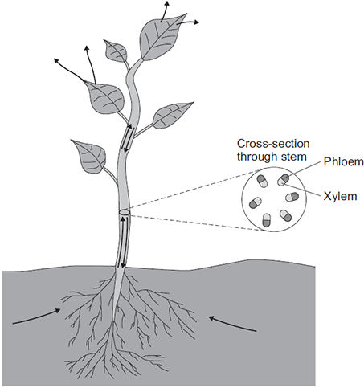
Describe how ions, water and sugar are obtained and transported through plants.
In your answer you should refer to materials moving upwards in a plant and to materials moving downwards in a plant.
_______________________________________________________________________
_______________________________________________________________________
_______________________________________________________________________
_______________________________________________________________________
_______________________________________________________________________
_______________________________________________________________________
_______________________________________________________________________
_______________________________________________________________________
_______________________________________________________________________
_______________________________________________________________________
_______________________________________________________________________
_______________________________________________________________________
_______________________________________________________________________
(6) (Total 10 marks)

Viral diseases
Week 4: Infectious diseases
Q7. Viruses and bacteria cause diseases in humans.
(a) Draw a ring around the correct word to complete the sentence.

 |  | algae.
 | Organisms that cause disease are called | pathogens.
 |  | vaccines.
(1)
(b) In August 2011 the United Nations gave a warning that there was a new strain of the bird flu virus in China.
Bird flu may kill humans. The new strain of the bird flu virus could cause a pandemic very quickly.
(i) What is a pandemic?
Tick () one box.

A disease affecting the people all over one country.
A disease affecting hundreds of people
A disease affecting people in many countries.
(1)
(ii) The swine flu virus is carried by pigs.
The bird flu virus is likely to spread much more quickly than the swine flu virus.
Suggest one reason why.
______________________________________________________________
______________________________________________________________
(1)
This notice is from a doctor’s surgery.

Unfortunately,
antibiotics
will NOT get
rid of your flu.
(c) (i) Why will antibiotics not get rid of flu?
______________________________________________________________
______________________________________________________________
(1)
(ii) The symptoms of flu include a sore throat and aching muscles.
What would a doctor give to a patient to relieve the symptoms of flu?
______________________________________________________________
(1)
(iii) It is important that antibiotics are not overused.
Explain why.
Use words from the box to complete the sentence.

antibody | bacteria | immune | resistant | viruses
Overuse of antibiotics might speed up the development
of __________________________ strains of _________________________ .
(2)
(Total 7 marks)
Vaccination
Q8. White blood cells protect the body against pathogens such as bacteria and viruses.
(a) (i) Pathogens make us feel ill.
Give one reason why.
______________________________________________________________
______________________________________________________________
(1)
(b) Vaccination can protect us from the diseases pathogens cause.
(i) One type of virus causes measles.
A doctor vaccinates a child against measles.
What does the doctor inject into the child to make the child immune to measles?
______________________________________________________________
______________________________________________________________
______________________________________________________________
______________________________________________________________
(2)
(ii) A few weeks after the vaccination, the child becomes infected with measles viruses from another person.
The graph shows the number of measles antibodies in the child’s blood from before the vaccination until after the infection.
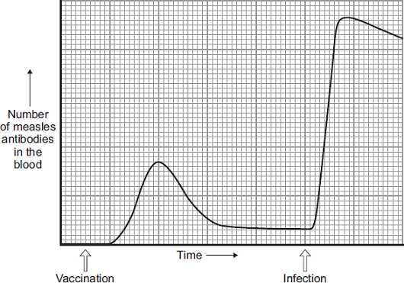
More measles antibodies are produced after the infection than after the vaccination.
Describe other differences in antibody production after infection compared with after vaccination.
______________________________________________________________
______________________________________________________________
______________________________________________________________
______________________________________________________________
______________________________________________________________
______________________________________________________________
(3)
(iii) Vaccination against the measles virus will not protect the child against the rubella virus.
Why?
______________________________________________________________
(1)

(c) What is the advantage of vaccinating a large proportion of the population against measles?
___________________________________________________________________
(1)
(d) Explain how vaccination makes a person immune to a disease.
___________________________________________________________________
___________________________________________________________________
___________________________________________________________________
___________________________________________________________________
___________________________________________________________________
___________________________________________________________________
___________________________________________________________________
___________________________________________________________________
___________________________________________________________________
___________________________________________________________________
(4) (Total 14 marks)
Producing monoclonal antibodies
Q9. A virus called RSV causes severe respiratory disease.
Week 5: Infectious diseases
(a) One treatment for RSV uses monoclonal antibodies which can be injected into the patient.
Scientists can produce monoclonal antibodies using mice.
The first step is to inject the virus into a mouse.
Describe the remaining steps in the procedure to produce monoclonal antibodies.
___________________________________________________________________
___________________________________________________________________
___________________________________________________________________
___________________________________________________________________
___________________________________________________________________
___________________________________________________________________
___________________________________________________________________
___________________________________________________________________
(3)
(c) Describe how injecting a monoclonal antibody for RSV helps to treat a patient suffering with the disease.
___________________________________________________________________
___________________________________________________________________
___________________________________________________________________
___________________________________________________________________
(2)
A trial was carried out to assess the effectiveness of using monoclonal antibodies to treat patients with RSV.
Some patients were given a placebo.
(d) Why were some patients given a placebo?
___________________________________________________________________
___________________________________________________________________
(1)
A number of patients had to be admitted to hospital as they became so ill with RSV.
The results are shown in the table below.

Treatment received by patient | % of patients within each group admitted to hospital with RSV
Group A: Monoclonal antibody for RSV | 4.8
Group B: Placebo | 10.4
The trial involved 1 500 patients.
• Half of the patients (group A) were given the monoclonal antibodies.
• Half of the patients (group B) were given the placebo.
(e) Evaluate how well the data in the table above supports the conclusion:
‘monoclonal antibodies are more effective at treating RSV than a placebo’.
___________________________________________________________________
___________________________________________________________________
___________________________________________________________________
___________________________________________________________________
(2)
(Total 8 marks)

Diagnosis and identification of plant diseases
Q10. To be healthy, plants need the right amount of mineral ions from the soil.
The diagram below shows four plants.
The plants were grown in four different growing conditions:
• sunny area, with nitrate and magnesium added to the soil
• sunny area, with magnesium but no nitrate added to the soil
• sunny area, with nitrate but no magnesium added to the soil
• dark area, with nitrate and magnesium added to the soil.
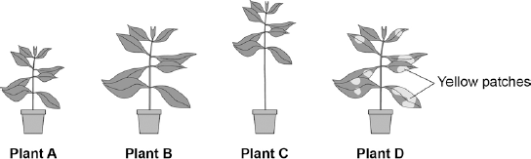
(a) Which plant was grown with no nitrate?

Tick one box.

A |  |  | B |  |  | C |  |  | D
(1)
(b) Which plant was grown with no magnesium?

Tick one box.

A |  |  | B |  |  | C |  |  | D
(1)
(c) Give one variable that was kept constant in this experiment.
___________________________________________________________________
___________________________________________________________________
(1)
(d) Plants need other minerals for healthy growth such as potassium ions and phosphate ions.
A farmer wanted to compare the percentage of minerals in two types of manure.
• Cow manure from her own farm.
• Chicken manure pellets she could buy.
The table below shows data for each type of manure.

 | Phosphate ions in % | Potassium ions in %
Cow manure | 0.4 | 0.5
Chicken manure pellets | 2.5 | 2.3
Suggest one advantage and one disadvantage of using the chicken manure pellets compared to the cow manure.
Advantage _________________________________________________________
___________________________________________________________________
Disadvantage _______________________________________________________
___________________________________________________________________
(2)
(Total 5 marks)
Uses of glucose
Week 6: Bioenergetics
Q11. Green plants can make glucose.
(a) Plants need energy to make glucose.
How do plants get this energy?
___________________________________________________________________
___________________________________________________________________
___________________________________________________________________
___________________________________________________________________
(2)
(b) Plants can use the glucose they have made to supply them with energy.
Give four other ways in which plants use the glucose they have made.
___________________________________________________________________
___________________________________________________________________
___________________________________________________________________
___________________________________________________________________
___________________________________________________________________
___________________________________________________________________
___________________________________________________________________
___________________________________________________________________
(4)
(Total 6 marks)

Respiration
Q12. Glucose is broken down in respiration.
(a) What is the chemical formula for glucose?
Tick one box.

C₆H₆O₆
C₃H₆O₃
C₆H₁₂O₆
C₆H₁₀O₆
(1)
The diagram shows the apparatus a student used to investigate aerobic respiration.
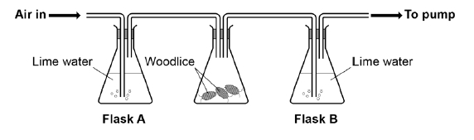
Limewater goes cloudy when carbon dioxide is added to it.
(b) After 10 minutes the limewater in flask B was cloudy, but the limewater in flask A remained colourless.
Explain why.
___________________________________________________________________
___________________________________________________________________
___________________________________________________________________
___________________________________________________________________
(2)
(c) Flask A acts as a control in this investigation.
What is the purpose of a control?
___________________________________________________________________
___________________________________________________________________
(1)
(d) The student repeated the investigation with no woodlice.
Describe the appearance of the limewater in flask A and flask B after 10 minutes.
Flask A ____________________________________________________________
___________________________________________________________________
Flask B ____________________________________________________________
___________________________________________________________________
(2)
Anaerobic respiration is another form of respiration in living organisms.
(e) What is produced during anaerobic respiration in humans?
Tick one box.

Carbon dioxide
Carbon dioxide and lactic acid
Lactic acid
Oxygen and water
(1)
(f) Complete the equation for anaerobic respiration in yeast.
glucose ⟶ carbon dioxide + ________________________
(1)
(Total 8 marks)

