Y11 Biology 1 PPE Foundation Topic list
For each topic, complete the questions that are in the Revision Guide. The page numbers you need are listed below.
Topic | Questions  Page Title |  | Support  Pages
Plant and bacterial cells | 26 | Cells and Microscopy | 11-13
Cell specialisation | 26 | Differentiation and Division | 14-16
5.1.1.5 Microscopy | 26 | Cells and Microscopy | 11-13
RPA osmosis | 26 | Exchanging Substances | 20-25
Digestive system | 45 | The Role of Enzymes | 28-32
Blood components | 45 | The Lungs and Circulatory System | 33-36
Plant diseases/deficiencies | 56 | Plant Diseases | 55
AIDS/HIV | 56 | Types of Disease | 46-48
Protist diseases | 56 |  | 46-48
4.3.1.9 Development and discovery of drugs | 56 | Fighting Disease | 49-51
RPA – Photosynthesis | 64 | Photosynthesis | 57-60
4.4.1.3 Uses of glucose | 64
Exam Practice
The following pages contain past exam questions that should attempt.
The grade for each question is indicated by:

Remember: to get Grade 4-5 you still have to be able to answer the 1-3 questions!

Plant and bacterial cells
Week 1: Cell biology

Q1. (a) The diagram shows the structure of a bacterial cell.
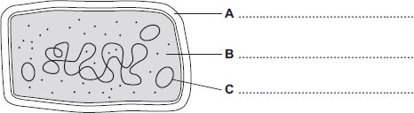
(i) On the diagram use words from the box to label structures A, B and C.

cell membrane | cell wall | chloroplast | cytoplasm | plasmid
(3)
(ii) Give one difference between the structure of the bacterial cell and an animal cell.
______________________________________________________________
(1)
(iii) Name one structure that is found in a plant cell but is not found in a bacterial or an animal cell.
______________________________________________________________
(1)
(b) The diagram shows two cells, a bacterial cell and a plant cell.
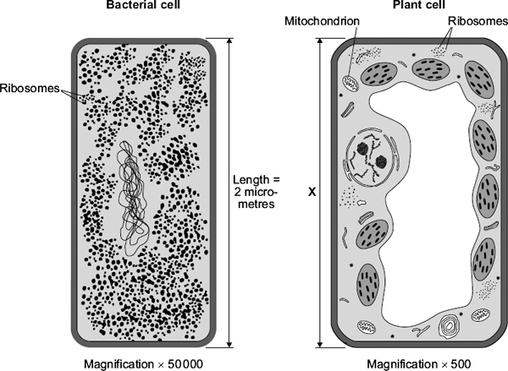

(i) Both the bacterial cell and the plant cell contain ribosomes.
What is the function of a ribosome?
______________________________________________________________
______________________________________________________________
(1)
(ii) The plant cell contains mitochondria but the bacterial cell does not contain mitochondria.
Give one other way in which the plant cell is different from the bacterial cell.
______________________________________________________________
______________________________________________________________
(1)
(Total 7 marks)
Cell specialisation
Q2. The diagrams show four types of cell, A, B, C and D. Two of the cells are plant cells and two are animal cells.
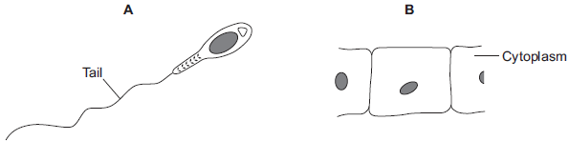
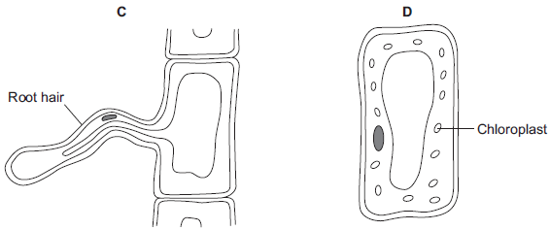
(a) (i) Which two of the cells are plant cells?
Tick () one box.

A and B
A and D
C and D
(1)
(ii) Give one reason for your answer.
______________________________________________________________
______________________________________________________________
(1)
(b) (i) Which cell, A, B, C or D, is adapted for swimming?
(1)
(ii) Which cell, A, B, C or D, can produce glucose by photosynthesis?
(1)
(c) Cells A, B, C and D all use oxygen.
For what process do cells use oxygen?
Draw a ring around one answer.

osmosis | photosynthesis | respiration
(1)
(d) Cells can be specialised for a particular job.
The diagram shows the structure of a human sperm cell.
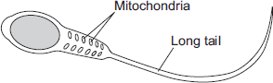
Describe how the long tail and the mitochondria help the sperm to do its job.
Long tail ___________________________________________________________
___________________________________________________________________
___________________________________________________________________
Mitochondria ________________________________________________________
___________________________________________________________________
___________________________________________________________________
(4)

(Total 5 marks)
5.1.1.5 Microscopy
Week 2: Cell biology

Q3. A student observed slides of onion cells using a microscope. Figure 2 shows two of the slides the student observed.
Figure 2
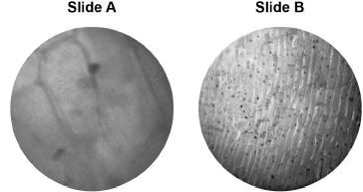
The cells on the slides are not clear to see.
(a) Describe how the student should adjust the microscope to see the cells on Slide A more clearly.
___________________________________________________________________
___________________________________________________________________
(1)
(b) Describe how the student should adjust the microscope to see the cells on Slide B more clearly.
___________________________________________________________________
___________________________________________________________________
___________________________________________________________________
(2)
(c) The student made the necessary adjustments to get a clear image. Figure 3 shows the student’s drawing of one of the cells.
Figure 3
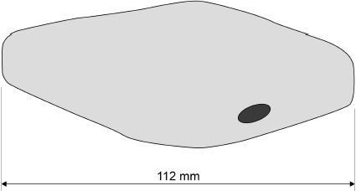
The real length of the cell was 280 micrometres (µm).
Calculate the magnification of the drawing.
___________________________________________________________________
___________________________________________________________________
___________________________________________________________________
___________________________________________________________________
___________________________________________________________________
Magnification = × _________________________
(3)
(Total 9 marks)
RPA osmosis
Q4.
In fish and chip shops, potatoes are cut into chips several hours before they are cooked.
The amount of water in the chips must be kept constant during this time.
To keep the water in the chips constant, the chips are kept in salt solution.
A student investigated the effect of different concentrations of salt solution on the mass of chips.
• He weighed each of five chips.
• He placed each chip into a different concentration of salt solution.
• After one hour he removed the chips, then reweighed them.
His results are shown in the table.
Concentration of salt  solution | 0 M | 0.5 M | 1 M | 2 M | 3 M
Mass of chip at start in  grams | 2.6 | 2.8 | 2.8 | 2.5 | 2.6
Mass of chip after one  hour in grams | 2.7 | 2.8 | 2.7 | 2.3 | 2.1
(a) (i) In which concentration of salt solution did the chip gain mass?
____________ M
(1)

(ii) Complete the sentence by drawing a ring around the correct answer in the box.

The chip gained mass because water entered by | digestion  osmosis  respiration
(1)
(b) In which concentration of salt solution should the chips be kept?
____________ M
Give a reason for your answer.
___________________________________________________________________
___________________________________________________________________
(2)
(c) How could the student have made his investigation more reliable?
___________________________________________________________________
___________________________________________________________________
(1)
(Total 5 marks)
Digestive system
Week 3: Organisation
Q5. The diagram below shows the human digestive system.
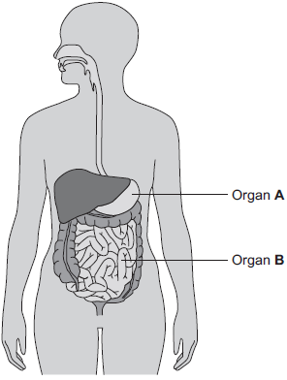
(a) (i) What is Organ A?
Draw a ring around the correct answer.
gall bladder liver stomach
(1)
(ii) What is Organ B?
Draw a ring around the correct answer.
large intestine pancreas small intestine
(1)
(b) Digestive enzymes are made by different organs in the digestive system.
Complete the table below putting a tick (✓) or cross (✕) in the boxes.
The first row has been done for you.

 |  | Organ producing enzyme
 |  | salivary glands | stomach | pancreas | small intestine
Enzyme | amylase | ✓ | ✕ | ✓ | ✓
 | lipase
 | protease
(2)
(c) The stomach also makes hydrochloric acid.
How does the acid help digestion?
___________________________________________________________________
___________________________________________________________________
(1)

(d) Draw one line from each digestive enzyme to the correct breakdown product.

Digestive enzyme |  | Breakdown products
 |  | amino acids.
Amylase breaks down starch into……
 |  | bases.
Lipase breaks down fats into…
 |  | fatty acids and glycerol.
Protease breaks down proteins into…
 |  | sugars.
(3)
(Total 8 marks)
Blood components
Q6. The bar chart shows the concentration of oxygen in the blood in three different blood vessels, X, Y and Z.
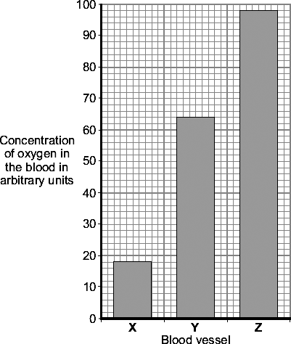
(a) (i) What is the concentration of oxygen in blood vessel X?
Answer _____________ arbitrary units.
(1)
(ii) Which blood vessel, X, Y or Z, carries blood from the lungs to the heart?
(1)
(b) Draw a ring around the correct answer to complete each sentence.

 |  | plasma.
(i) | Most of the oxygen in the blood is carried by the | red blood cells.
 |  | white blood cells.
(1)
(ii) Oxygen combines with a coloured pigment in the blood.

 | alveoli.
This coloured pigment is called | haemoglobin.
 | lactic acid.
(1)
(Total 4 marks)
Plant diseases/deficiencies
Q7.
Week 4: Infectious diseases
Plants need mineral ions for healthy growth.
(a) Which part of a plant takes in mineral ions?
Tick () one box.

Flower
Leaf
Root
(1)
(b) Leaves are usually green.
(i) What is the green substance in leaves?
Draw a ring around your answer.

chlorophyll | glucose | starch
(1)
(ii) The green substance in leaves is important to plants.
Explain why.
______________________________________________________________
______________________________________________________________
______________________________________________________________
______________________________________________________________
(2)
(c) A shortage of mineral ions can affect a plant.
Draw one line from each mineral ion to the effect of its shortage.

Mineral ion |  | Effect of its shortage
 |  | Yellow leaves
Magnesium
 |  | Stunted growth
Nitrate
 |  | White flowers
(2)
(Total 6 marks)

Viral diseases
Q8. Viruses and bacteria cause diseases in humans.
(a) Draw a ring around the correct word to complete the sentence.

 |  | algae.
 | Organisms that cause disease are called | pathogens.
 |  | vaccines.
(1)
(b) In August 2011 the United Nations gave a warning that there was a new strain of the bird flu virus in China.
Bird flu may kill humans. The new strain of the bird flu virus could cause a pandemic very quickly.
(i) What is a pandemic?
Tick () one box.

A disease affecting the people all over one country.
A disease affecting hundreds of people
A disease affecting people in many countries.
(1)
(ii) The swine flu virus is carried by pigs.
The bird flu virus is likely to spread much more quickly than the swine flu virus.
Suggest one reason why.
______________________________________________________________
______________________________________________________________
(1)
This notice is from a doctor’s surgery.

Unfortunately,
antibiotics
will NOT get
rid of your flu.
(c) (i) Why will antibiotics not get rid of flu?
______________________________________________________________
______________________________________________________________
(1)
(ii) The symptoms of flu include a sore throat and aching muscles.
What would a doctor give to a patient to relieve the symptoms of flu?
______________________________________________________________
(1)
(iii) It is important that antibiotics are not overused.
Explain why.
Use words from the box to complete the sentence.

antibody | bacteria | immune | resistant | viruses
Overuse of antibiotics might speed up the development
of __________________________ strains of _________________________ .
(2)
(Total 7 marks)
Week 5: Infectious diseases

Protist diseases
Q9. Pathogens cause infectious diseases in animals and plants.
(a) Draw one line from each disease to the type of pathogen that causes the disease.

Disease |  | Type of pathogen
 |  | Bacterium
Gonorrhoea
 |  | Fungus
Malaria
 |  | Protist
Measles
 |  | Virus
(3)
(b) Some parts of the human body have adaptations to reduce the entry of live pathogens.
Look at Figure 1.
Figure 1
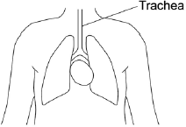
Explain how the trachea is adapted to reduce the entry of live pathogens.
___________________________________________________________________
___________________________________________________________________
___________________________________________________________________
___________________________________________________________________
___________________________________________________________________
___________________________________________________________________
___________________________________________________________________
___________________________________________________________________
___________________________________________________________________
(4)
(c) Malaria is a serious disease that can be fatal.
Malaria is spread to humans by infected mosquitoes.
Scientists investigated the behaviour of mosquitoes to understand how the spread of malaria could be controlled.
Figure 2 shows the equipment the scientists used.
Figure 2
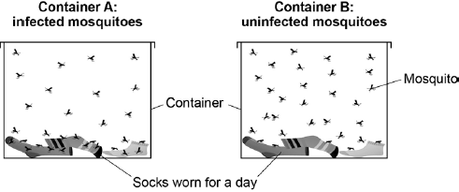
This is the method used.
1. 30 mosquitoes infected with malaria were placed in Container A.
2. 30 uninfected mosquitoes were placed in Container B.
3. The total number of times the mosquitoes landed on the socks was recorded.
Name the dependent variable and suggest one control variable in this investigation.
Dependent variable ___________________________________________________
___________________________________________________________________
Control variable ______________________________________________________
___________________________________________________________________
(2)
(d) Infected mosquitoes landed on the socks three times more often than uninfected mosquitoes.
Explain how this information can be used to reduce the spread of malaria.
___________________________________________________________________
___________________________________________________________________
___________________________________________________________________
___________________________________________________________________
(2)
(Total 11 marks)

4.3.1.9 Development and discovery of drugs
Q10. Medicinal drugs are used to treat diseases.
(a) Draw one line from each drug to its correct use.

Drug |  | Use
 |  | Used as a fertility drug
Painkiller
 |  | Used to relieve disease symptoms
Statin
 |  | Used to treat leprosy
Thalidomide
 |  | Used to lower blood cholesterol
(3)
(b) New drugs need to be tested before going on sale.
The diagram shows a time line for the testing of a new drug.
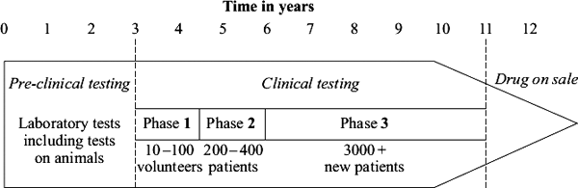
(i) How long do trials on humans take? _________________ years
(1)
(ii) What is the minimum number of humans the drug is tested on throughout clinical testing?
_________________
(1)

(c) Draw a ring around the correct answer to complete each sentence.

 |  | if it is toxic.
(i) | A new drug is first tested in the laboratory to find | if it is cost effective.
 |  | the optimum dose.
(1)

 |  | if it is cost effective.
(ii) | The drug is then tested on a few volunteers to find | if it has side effects.
 |  | the optimum dose.
(1)
(Total 7 marks)
RPA – Photosynthesis
Week 6: Bioenergetics
Q11. A student investigated the effect of light intensity on the rate of photosynthesis.
The diagram shows the apparatus the student used.
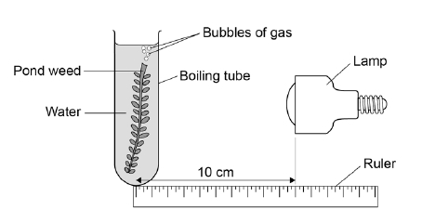
This is the method used.
1. Set up the apparatus as shown in the diagram above.
2. Place the lamp 10 cm from the pondweed.
3. Turn the lamp on and count the number of bubbles produced in one minute.
4. Repeat with the lamp at different distances from the pondweed.
(a) Complete the hypothesis for the student’s investigation.
‘As light intensity increases, ____________________________________________
_________________________________________________________________ .’
(1)
(b) What was the independent variable in this investigation?
Tick one box.

Light intensity
Number of bubbles produced
Temperature
Time
(1)
(c) The teacher suggests putting the boiling tube into a beaker of water during the investigation.
Suggest why this would make the results more valid.
___________________________________________________________________
___________________________________________________________________
(1)
Table 1 shows the student’s results.

Table 1
Distance of lamp from pondweed in cm | Number of bubbles produced per minute
 | Trial 1 | Trial 2 | Trial 3 | Mean
10 | 67 | 66 | 69 | 67
20 | 61 | 64 | 62 | 62.3
30 | 53 | 51 | 52 | X
40 | 30 | 32 | 31 | 31
50 | 13 | 15 | 15 | 14
(d) Calculate value X in Table 1.
___________________________________________________________________
___________________________________________________________________
X = ____________________ bubbles per minute
(1)

(e) State one error the student has made when completing the results at 20 cm.
___________________________________________________________________
___________________________________________________________________
(1)
(f) What evidence in Table 1 shows that the data is repeatable?
Tick one box.

The number of bubbles decreases as distance decreases.
The numbers of bubbles at each distance are similar.
The student calculated a mean for each distance.
The student did the experiment three times.
(1)
Another student investigated the effect of the colour of light on the rate of photosynthesis.
The results are shown in Table 2.

Table 2
Colour of light | Rate of photosynthesis in arbitrary units
Blue | 24
Green | 4
Red | 17
Yellow | 8
(g) Plot the data from Table 2 on the graph.
You should label the x-axis.
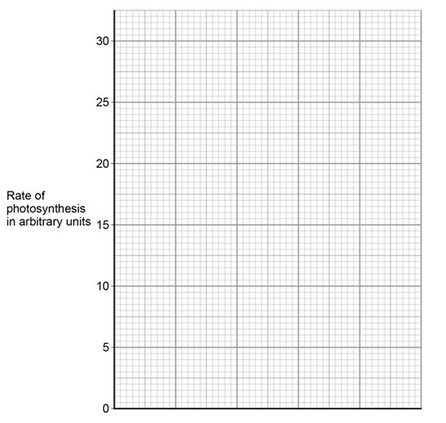
(3)
(h) Give two conclusions from the graph above.
1. _________________________________________________________________
___________________________________________________________________
2. _________________________________________________________________
___________________________________________________________________
(2)
(i) The glucose produced in photosynthesis can be converted into amino acids to make new proteins for the plant.
Complete the sentences.
The glucose produced in photosynthesis can also be used in other ways.
Glucose can be used in respiration to release _________________ .
Glucose can be converted to cellulose to strengthen the _________________ .
Glucose can be stored as _________________ .
(3)
(Total 14 marks)
4.4.1.3 Uses of glucose
Q12. (a) Complete the word equation for photosynthesis.

carbon dioxide + water | energy | glucose + ______
(1)
(b) Draw a ring around the correct answer to complete each sentence.

(i) | The energy needed for photosynthesis comes from | light.  osmosis.  respiration.
(1)

(ii) | Energy is absorbed by a green pigment called | chloride.  chloroplast.  chlorophyll.
(1)

(iii) | If the temperature is decreased the rate of photosynthesis will | decrease.  increase.  stay the same.
(1)
(c) Give three ways in which plants use the glucose made in photosynthesis.
1. _________________________________________________________________
___________________________________________________________________
2. _________________________________________________________________
___________________________________________________________________
3. _________________________________________________________________
___________________________________________________________________
(3)
(Total 7 marks)

