Y11 Chemistry 1 PPE Higher Topic list
The topics below will be assessed in your next PPE

Atomic structure and the periodic table
- Group 7
Bonding
- Ionic bonding
- Metallic bonding
- Metals and alloys
Chemical changes
- Strong and weak acids
- pH scale and neutralisation
- electrolysis- aluminium oxide
Energy transfer
- RPA- metals and acid
- Bond energy

Exam Practice
The following pages contain past exam questions that should attempt.
The grade for each question is indicated by:

Remember: to get Grade 7, 8 or 9 you still have to be able to answer the 4-5 questions!

Q1.
The halogens are in Group 7 of the periodic table.
(a) Why, in terms of electrons, are the halogens in Group 7?
___________________________________________________________________
___________________________________________________________________
(1)
(b) Sea water contains bromide ions (Br⁻).
The bromide ions can be changed to bromine by bubbling chlorine gas into sea water.
Chlorine is able to displace bromine from sea water because chlorine is more reactive than bromine.

2Br⁻(aq) | + | Cl₂(g) | → | Br₂(g) | + | 2Cl⁻(aq)
Explain, in terms of electrons, why chlorine is more reactive than bromine.
___________________________________________________________________
___________________________________________________________________
___________________________________________________________________
___________________________________________________________________
___________________________________________________________________
___________________________________________________________________
___________________________________________________________________
___________________________________________________________________
(3)
(Total 4 marks)
Q2.
This question is about magnesium and magnesium chloride.
(a) Magnesium chloride contains magnesium ions (Mg²⁺) and chloride ions (Cl⁻).
Describe, in terms of electrons, what happens when a magnesium atom reacts with chlorine atoms to produce magnesium chloride.
___________________________________________________________________
___________________________________________________________________
___________________________________________________________________
___________________________________________________________________
___________________________________________________________________
___________________________________________________________________
___________________________________________________________________
___________________________________________________________________
(4)
(b) Magnesium chloride can be electrolysed.
The diagram below shows two experiments for electrolysing magnesium chloride.
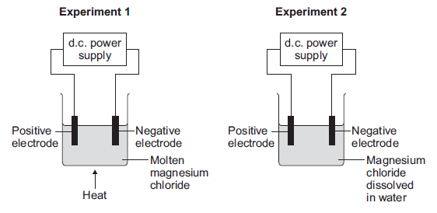
(i) Explain why magnesium chloride must be molten or dissolved in water to be electrolysed.
______________________________________________________________
______________________________________________________________
______________________________________________________________
______________________________________________________________
(2)
(c) Magnesium is a metal.
Explain why metals can be bent and shaped.
___________________________________________________________________
___________________________________________________________________
___________________________________________________________________
___________________________________________________________________
(2)
(Total 14 marks)
Q3.
This question is about different substances and their structures.
(a) Draw one line from each statement to the diagram which shows the structure.
Statement Structure
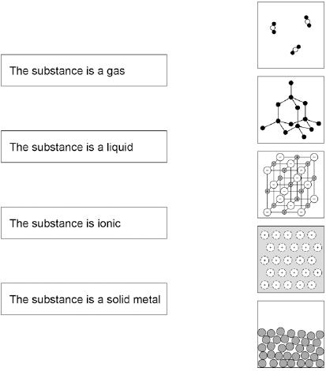
(4)

(b) Figure 2 shows the structure of an alloy.
Figure 2
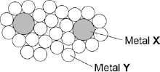
Explain why this alloy is harder than the pure metal Y.
___________________________________________________________________
___________________________________________________________________
___________________________________________________________________
___________________________________________________________________
(2)
(c) What percentage of the atoms in the alloys are atoms of X?
___________________________________________________________________
___________________________________________________________________
___________________________________________________________________
___________________________________________________________________
(2)
(d) What type of substance is an alloy?

Tick one box.
Compound
Element
Mixture
(1)
(Total 11 marks)
Q4.
The table shows some information about acids and alkalis.

Name of acid  or alkali | Type | Ions produced in  solution |  | pH | Effect on Universal  Indicator
Hydrochloric acid | Strong acid | H⁺ | Cl– | 1 | Goes red
Sodium hydroxide | Strong alkali | Na⁺ | OH– | 13 | Goes purple
Use the information in the table to help you answer parts (a) and (b).
(a) Draw a ring around the correct answer to complete each sentence.
(i) Hydrochloric acid is acidic.

 |  | Cl⁻
 | This is because it contains | H⁺ | ions
 |  | OH⁻
(1)
(ii) Sodium hydroxide solution is alkaline.

 |  | H⁺
 | This is because it contains | Na⁺ | ions
 |  | OH⁻
(1)

 |  |  | higher than
 | (iii) | The pH of acids is | lower than | the pH of alkalis.
 |  |  | the same as
(1)
(b) Ethanoic acid is a weak acid.
Universal Indicator can be used to show that hydrochloric acid is a stronger acid than ethanoic acid of the same concentration.
Explain how.
___________________________________________________________________
___________________________________________________________________
___________________________________________________________________
___________________________________________________________________
(2)
(c) Draw a ring around the correct answer to complete this sentence.

 | completely
Strong acids and strong alkalis are | not | ionised in water.
 | partially
(1)
(d) The diagram shows the apparatus used to find the volume of hydrochloric acid that reacts with 25.0 cm³ of sodium hydroxide solution.
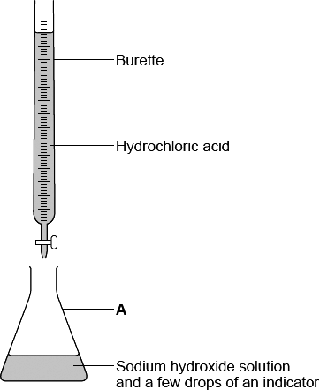
(i) Which one of the following is the correct name for A?
Draw a ring around your answer.

beaker | conical flask | pipette
(1)
(ii) Use the correct word from the box to complete the sentence.

distillation | filtration | titration
The method used to find the volume of acid that reacts with a known volume
of alkali is __________________________________ .
(1)
(iii) Suggest one way to make the results more reliable.
______________________________________________________________
(1)
(Total 9 marks)
Q5.
Sodium hydroxide neutralises sulfuric acid.
The equation for the reaction is:
2NaOH + H₂SO₄ → Na₂SO₄ + 2H₂O
(a) Sulfuric acid is a strong acid.
What is meant by a strong acid?
___________________________________________________________________
___________________________________________________________________
___________________________________________________________________
(2)
(b) Write the ionic equation for this neutralisation reaction. Include state symbols.
___________________________________________________________________
(2)
(c) A student used a pipette to add 25.0 cm³ of sodium hydroxide of unknown concentration to a conical flask.
The student carried out a titration to find out the volume of 0.100 mol / dm³ sulfuric acid needed to neutralise the sodium hydroxide.
Describe how the student would complete the titration.
You should name a suitable indicator and give the colour change that would be seen.
___________________________________________________________________
___________________________________________________________________
___________________________________________________________________
___________________________________________________________________
___________________________________________________________________
___________________________________________________________________
___________________________________________________________________
___________________________________________________________________
___________________________________________________________________
___________________________________________________________________
(4)
(d) The student carried out five titrations. Her results are shown in the table below.

 | Titration 1 | Titration 2 | Titration 3 | Titration 4 | Titration 5
Volume of 0.100 mol / dm³ sulfuric acid in cm³ | 27.40 | 28.15 | 27.05 | 27.15 | 27.15
Concordant results are within 0.10 cm³ of each other.
Use the student’s concordant results to work out the mean volume of 0.100 mol / dm³ sulfuric acid added.
___________________________________________________________________
___________________________________________________________________
___________________________________________________________________
___________________________________________________________________
Mean volume = _____________________________ cm³
(2)
(e) The equation for the reaction is:
2NaOH + H₂SO₄ → Na₂SO₄ + 2H₂O
Calculate the concentration of the sodium hydroxide.
Give your answer to three significant figures.
___________________________________________________________________
___________________________________________________________________
___________________________________________________________________
___________________________________________________________________
___________________________________________________________________
___________________________________________________________________
___________________________________________________________________
Concentration = _______________________ mol / dm³
(4)
(f) The student did another experiment using 20 cm³ of sodium hydroxide solution with a concentration of 0.18 mol / dm³.
Relative formula mass (M_{r}) of NaOH = 40
Calculate the mass of sodium hydroxide in 20 cm³ of this solution.
___________________________________________________________________
___________________________________________________________________
___________________________________________________________________
___________________________________________________________________
Mass = ________________ g
(2)
(Total 16 marks)
Q6.
A student investigated the temperature change when zinc reacts with copper sulfate solution.
The student used a different concentration of copper sulfate solution for each experiment.
The student used the apparatus shown below.
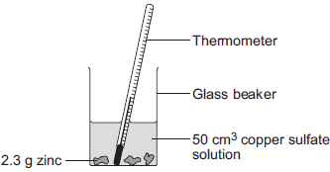
The student:
• measured 50 cm³ copper sulfate solution into a glass beaker
• measured the temperature of the copper sulfate solution
• added 2.3 g zinc
• measured the highest temperature
• repeated the experiment using copper sulfate solution with different concentrations.
The equation for the reaction is:
Zn(s) + CuSO₄(aq) Cu(s) + ZnSO₄(aq)
zinc + copper sulfate solution copper + zinc sulfate solution
(a) The thermometer reading changes during the reaction.
Give one other change the student could see during the reaction.
___________________________________________________________________
___________________________________________________________________
(1)
(b) Suggest one improvement the student could make to the apparatus.
Give a reason why this improves the investigation.
Improvement ________________________________________________________
___________________________________________________________________
Reason ____________________________________________________________
___________________________________________________________________
(2)
(c) In this question you will be assessed on using good English, organising information clearly and using specialist terms where appropriate.
The student’s results are shown in the table below.

Experiment number | Concentration of  copper sulfate  in moles per dm³ | Increase in temperature in °C
1 | 0.1 | 5
2 | 0.2 | 10
3 | 0.3 | 12
4 | 0.4 | 20
5 | 0.5 | 25
6 | 0.6 | 30
7 | 0.7 | 35
8 | 0.8 | 35
9 | 0.9 | 35
10 | 1.0 | 35
Describe and explain the trends shown in the student’s results.
___________________________________________________________________
___________________________________________________________________
___________________________________________________________________
___________________________________________________________________
___________________________________________________________________
___________________________________________________________________
___________________________________________________________________
___________________________________________________________________
___________________________________________________________________
___________________________________________________________________
(6)
(Total 9 marks)
Q7.
Cells contain chemicals which react to produce electricity.
(a) Why can a rechargeable cell be recharged?
___________________________________________________________________
___________________________________________________________________
(1)
(b) Give two factors that affect the voltage produced by a cell.
1. _________________________________________________________________
2. _________________________________________________________________
(2)
(c) Balance the half-equation for the reaction occurring at an electrode in one type of hydrogen fuel cell.
H₂ + OH⁻ ⟶ H₂O + e⁻
(1)
(d) Why is the fuel cell in Question (c) described as an alkaline fuel cell?
___________________________________________________________________
___________________________________________________________________
(1)
(e) Another type of fuel cell uses methanol instead of hydrogen.
The diagram represents the reaction in this fuel cell.
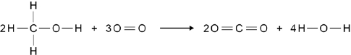
The table shows the bond energies for the reaction.

 | C–H | C–O | O–H | O=O | C=O
Bond energy in kJ / mol | 412 | 360 | 464 | 498 | 805
Calculate the overall energy change for the reaction.
Use the diagram and the table above.
___________________________________________________________________
___________________________________________________________________
___________________________________________________________________
___________________________________________________________________
___________________________________________________________________
___________________________________________________________________
Overall energy change = ____________________ kJ / mol
(3)
(Total 8 marks)

