Y11 Combined Biology 1
PPE 2 - Higher
For each topic, there are questions in the Revision Guide that will help you choose what to revise. The page numbers you need are listed below.
Topic | Questions  Page Title |  | Support  Pages
Eukaryotic and prokaryotic cells | 23 | Cells and microscopy | 11-13
Microscopy | 23 |  | 11-13
RPA: Osmosis | 23 | Exchanging substances | 17-22
Enzymes | 42 | The Role of Enzymes and Food Tests | 25-29
Transpiration | 42 | Plant Cell Organisation and Transport | 39-41
Coronary heart disease | 42 | Diseases and risk factors | 34-38
Viral diseases | 57 | Types of disease | 43-45
Discovery of drugs | 57 | Fighting Disease | 46-49
Photosynthesis | 57 | Photosynthesis | 50-53
Respiration | 57 | Respiration and metabolism | 54-56

Exam Practice
The following pages contain past exam questions that should attempt.
The grade for each question is indicated by:

Remember: to get Grade 7, 8 or 9 you still have to be able to answer the 4-5 questions!

Biology 1 Checklist
PPE 2 - Foundation

What you need to know and be able to do.
Once you feel confident with a topic, tick the box to show that you have revised this. You will still need to keep going over it though!

Cells
- Describe the structure and components of eukaryotic and prokaryotic cells
- Calculate magnification
- RPA- osmosis- interpret secondary data on the RPA on osmosis

Organisation
- Describe and explain how ions, sugars and water are transported in the plants
- Describe and explain risk factors that contribute to CHD
- Interpret data on activity of enzymes

Infectious disease
- Interpret data on vaccinations
- Explain how vaccination reduce the spread of viruses in populations
- Describe and explain how vaccination leads to immunity
- Apply knowledge to interpret information and data about the results of drug testing.

Bioenergetics
- Describe aerobic and anaerobic respiration

4/6 Mark Questions  All science papers will contain at least one extended writing question.  These will be either 4 or 6 marks.  The criteria for each type of question is always the same.  This page shows you the criteria for reaching each level on a 6 mark question based on the command word. | Design/Plan  Level 3: The design/plan would lead to the production of a valid outcome. All key steps are identified and logically sequenced.  Level 2: The design/plan would not necessarily lead to a valid outcome. Most steps are identified, but the plan is not fully logically sequenced.  Level 1: The design/plan would not lead to a valid outcome. Some relevant steps are identified, but links are not made clear.
Compare  Level 2: Scientifically relevant features are identified: the way(s) in which they are similar/different is made clear and (where appropriate) the magnitude of the similarity/difference is noted.  Level 1: Relevant features are identified and differences noted.  No relevant content | Evaluate  Level 3: A judgement, strongly linked and logically supported by a sufficient range of correct reasons, is given  Level 2: Some logically linked reasons are given. There may also be a simple judgement.  Level 1: Relevant points are made. They are not logically linked.
Describe  Level 2: Scientifically relevant facts, events or processes are identified and given in detail to form an accurate account.  Level 1: Facts, events or processes are identified and simply stated but their relevance is not clear.  No relevant content | Explain  Level 3: Relevant points (reason/causes) are identified, given in detail and logically linked to form a clear account.  Level 2: Relevant points (reason/causes) are identified, and there are attempts at logical linking. The resulting account is not fully clear.  Level 1: Points are identified and stated simply, but the relevant is not clear and there is no attempt at logical linking.

Cells and Microscopy
Q1.
Figure 1 shows an animal cell and a bacterial cell.
Figure 1
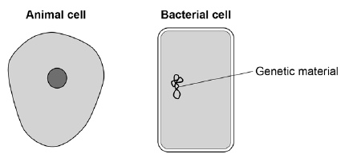
(a) Compare the structure of the cells in Figure 1.
Complete the sentences.
Choose the answers from the box.

cell membrane | cell wall | chloroplast
cytoplasm |  | nucleus
Only the animal cell contains a _________________________________________ .
Only the bacterial cell contains a _______________________________________ .
(2)
Figure 2 shows a section through a leaf.
Figure 2
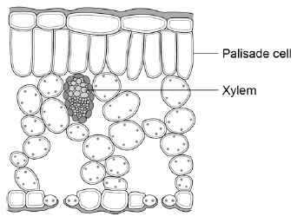
(b) The function of palisade cells is to photosynthesise.
Describe one way palisade cells are adapted to carry out their function.
___________________________________________________________________
___________________________________________________________________
(1)
(c) Complete Table 1 to show whether each structure is a tissue, an organ or an organ system.
Tick one box for each structure.

Table 1
Structure | Tissue | Organ | Organ system
Leaf
Xylem
Roots, stem and leaves
(2)
A student observed palisade cells using a microscope.
The microscope had four objective lenses, each with a different magnification.
(d) Which objective lens should the student use first?
Tick one box.
Give a reason for your answer.

×4 magnification
×10 magnification
×40 magnification
×100 magnification
Reason ____________________________________________________________
___________________________________________________________________
(2)
The student measured the width of 5 different palisade cells at a total magnification of ×400
(e) Eyepiece lenses are usually ×5 or ×10 magnification.
What combination of eyepiece and objective lenses would give a total magnification of ×400?
Eyepiece lens ____________________
Objective lens ____________________
(1)
(f) Table 2 shows the student’s results.

Table 2
Cell | Width of cell image in mm
1 | 12
2 | 13
3 | 16
4 | 10
5 | 11
(f) Calculate the mean width of the palisade cell images.
___________________________________________________________________
___________________________________________________________________
Mean width = ____________________ mm
(1)
(g) Calculate the real width of a palisade cell.
Use the mean width you calculated in part (f).
Use the equation:
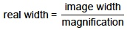
___________________________________________________________________
___________________________________________________________________
Real width = ____________________ mm
(2)
(Total 11 marks)
Cells and Microscopy
Q2.
The figure below shows four different types of cell.
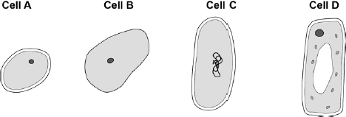
(a) Which cell is a plant cell?
Give one reason for your answer.
Cell _________
Reason ____________________________________________________________
(2)
(b) Which cell is an animal cell?
Give one reason for your answer.
Cell _________
Reason ____________________________________________________________
(2)
(c) Which cell is a prokaryotic cell?
Give one reason for your answer.
Cell _________
Reason ____________________________________________________________
(2)
(d) A scientist observed a cell using an electron microscope.
The size of the image was 25 mm.
The magnification was × 100 000
Calculate the real size of the cell.
Use the equation:
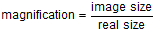
Give your answer in micrometres.
___________________________________________________________________
___________________________________________________________________
Real size = __________________ micrometres
(3)
(Total 9 marks)
Osmosis
Q3.
Cells, tissues and organs are adapted to take in different substances and get rid of different substances.
The table shows the concentration of four ions outside cells and inside cells.

Ion | Concentration outside cells in mmol per dm³ | Concentration inside cells in mmol per dm³
Sodium | 140 | 9
Potassium | 7 | 138
Calcium | 2 | 27
Chloride | 118 | 3
(a) Use information from the table above to complete the following sentences.
Sodium ions will move into cells by the process
of __________________________________ .
Potassium ions will move into cells by the process
of __________________________________ .
(2)
(b) Some students investigated the effect of the different concentrations of sugar in four drinks, A, B, C and D, on the movement of water across a partially permeable membrane.
The students:
• made four bags from artificial partially permeable membrane
• put equal volumes of 5% sugar solution in each bag
• weighed each bag containing the sugar solution
• placed one bag in each of the drinks, A, B, C and D
• after 20 minutes removed the bags containing the sugar solution and weighed them again.
The diagram below shows how they set up the investigation.
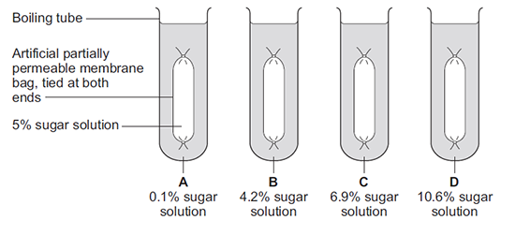
(i) The bag in drink A got heavier after 20 minutes.
Explain why.
______________________________________________________________
______________________________________________________________
______________________________________________________________
______________________________________________________________
(3)
(ii) In which drink, A, B, C or D, would you expect the bag to show the smallest change in mass?

Tick (✔) one box.

A |  |  | B |  |  | C |  |  | D
(1)
(iii) Explain why you think the bag you chose in part (b)(ii) would show the smallest change.
______________________________________________________________
______________________________________________________________
______________________________________________________________
______________________________________________________________
(2)
(Total 8 marks)
Enzymes
Q4.
The body uses enzymes to digest (break down) large food molecules into smaller molecules.
(a) (i) Draw one line from each large food molecule to the enzyme that acts on it.

Large food  molecule |  | Enzyme
 |  | amylase
starch
 |  | protease
fat
 |  | lipase
protein
 |  | isomerase
(3)
(ii) Draw a ring around the correct answer to complete each sentence.

 | amino acids.
Starch is broken down into | fatty acids and glycerol.
 | sugars.

 | amino acids.
Fat is broken down into | fatty acids and glycerol.
 | fructose.

 | amino acids.
Protein is broken down into | fructose.
 | sugars.
(3)
(b) Bile helps digestion.
Where is bile produced?
Draw a ring around one answer.

liver | mouth | stomach
(1)
(Total 7 marks)
Enzymes
Q5.
There are enzymes in biological washing powders. Biological washing powder has to be used at temperatures below 45 °C.
(a) The enzymes in biological washing powders do not work on the stains on clothes at temperatures above 45 °C.
Explain why.
___________________________________________________________________
___________________________________________________________________
___________________________________________________________________
___________________________________________________________________
(2)
(b) Some bacteria, called thermophilic bacteria live in hot springs at temperatures of 80 °C.
Scientists have extracted enzymes from these thermophilic bacteria. These enzymes are being trialled in industrial laundries.
The laundries expect to increase the amount of clothes they can clean by using enzymes from thermophilic bacteria instead of using the biological washing powders the laundries use now.
(i) The laundries expect to be able to increase the amount of clothes that they can clean each day.
Suggest why.
______________________________________________________________
______________________________________________________________
______________________________________________________________
______________________________________________________________
______________________________________________________________
(2)
(ii) Using washing powders with enzymes from thermophilic bacteria may be more harmful to the environment than using the biological washing powders that laundries use now.
Suggest why.
______________________________________________________________
______________________________________________________________
______________________________________________________________
______________________________________________________________
______________________________________________________________
(2)
(Total 6 marks)
Transpiration
Q6.
The image below shows some cells on the lower surface of a leaf.
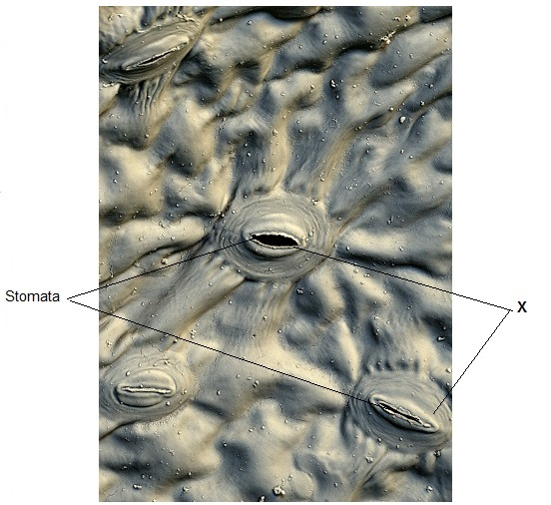
© Stefan Diller/Science Photo Library
(a) What are the cells labelled X called?
Draw a ring around the correct answer.
guard cells palisade cells mesophyll cells
(1)
(b) Water loss by evaporation from leaves is called transpiration.
A student set up an experiment to investigate water loss from leaves.
The student:
• took two leaves, A and B, from a plant
• put Vaseline (grease) on both sides of Leaf B; did nothing to Leaf A
• wrote down the mass of each leaf
• attached the leaves onto a string as shown in the diagram below.
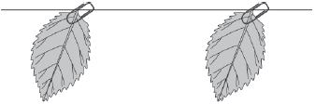
Leaf A  (no treatment) | Leaf B  (both surfaces covered in Vaseline)
• left the leaves for 48 hours
• wrote down the mass of each leaf again
• calculated the percentage (%) change in mass for each leaf.
(i) Give one variable that the student controlled in this investigation.
______________________________________________________________
______________________________________________________________
(1)
(ii) The mass of Leaf A was 1.60 g at the start of the investigation. After 48 hours it was 1.28 g.
Calculate the % decrease in mass over 48 hours.
______________________________________________________________
______________________________________________________________
% decrease = __________________
(2)
(c) Vaseline blocks the stomata.
The % change in mass of Leaf B was less than Leaf A after 48 hours.
Explain why.
___________________________________________________________________
___________________________________________________________________
___________________________________________________________________
(1)
(d) Give three environmental conditions that would increase transpiration.
1. _________________________________________________________________
2. _________________________________________________________________
3 _________________________________________________________________
(3)
(Total 8 marks)
Coronary Heart Disease
Q7.
Coronary heart disease (CHD) is a non-communicable disease.
CHD is caused when fatty material builds up in the coronary arteries.
(a) Explain what a non-communicable disease is.
___________________________________________________________________
___________________________________________________________________
___________________________________________________________________
___________________________________________________________________
(2)
The diagram below shows a coronary artery of someone with CHD.
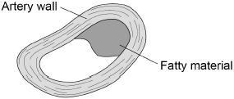
(b) Explain how CHD can cause a heart attack.
___________________________________________________________________
___________________________________________________________________
___________________________________________________________________
___________________________________________________________________
___________________________________________________________________
___________________________________________________________________
(3)
(c) Explain how lifestyle and medical risk factors increase the chance of developing CHD.
___________________________________________________________________
___________________________________________________________________
___________________________________________________________________
___________________________________________________________________
___________________________________________________________________
___________________________________________________________________
___________________________________________________________________
___________________________________________________________________
___________________________________________________________________
___________________________________________________________________
___________________________________________________________________
___________________________________________________________________
(6)
(Total 11 marks)

Viral Diseases
Q8.
Hepatitis B is a liver disease caused by a virus. The virus is found in body fluids such as blood, saliva and urine. Diagram 1 shows the structure of the virus in cross section.
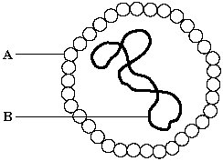
Diagram 1
(a) The human body has several natural defences against viruses. Some of these prevent viruses from entering the body. Others act once the viruses have entered.
(i) Diagram 2 shows a white blood cell attacking a group of viruses.
Complete diagram 2 by drawing the 2nd stage.
1st stage 2nd stage 3rd Stage
Diagram 2
(1)

(ii) What type of chemical is released by some white blood cells to attack viruses?
______________________________________________________________
(1)
(b) Hepatitis B is more likely to be spread among people who share needles when they inject drugs. Use information given at the beginning of this question to explain why this is so.
___________________________________________________________________
___________________________________________________________________
___________________________________________________________________
___________________________________________________________________
(2)
(Total 4 marks)
Viral Diseases and Developing Drugs
Q9.
In 2014 there was an outbreak of Ebola virus disease (EVD) in Africa.
At the time of the outbreak there were:
• no drugs to treat the disease
• no vaccines to prevent infection.
(a) By March 2015 there were an estimated 9850 deaths worldwide from EVD.
The number of deaths is an estimate.
Suggest why it is an estimate rather than an exact number.
___________________________________________________________________
___________________________________________________________________
(1)
(b) Why were no antibiotics used to treat EVD?
___________________________________________________________________
___________________________________________________________________
___________________________________________________________________
(1)
(c) After the outbreak began, drug companies started to develop drugs and vaccines for EVD.
A drug has to be thoroughly tested and trialled before it is licensed for use.
Testing, trialling and licensing new drugs usually takes several years.
Draw one line from each word about drug testing to the definition of the word.

Word about drug testing |  |  |  | Definition
 | Dose |  |  | Side effects making the person ill
 | Efficacy |  |  | The concentration of the drug to be used and how often the drug should be given
 | Toxicity |  |  | Whether the drug works to treat the illness
(2)
(d) The results of drug testing and drug trials are studied in detail by other scientists.
Only then can the results be published by the drug company.
Suggest one reason why the results are studied by other scientists.
___________________________________________________________________
___________________________________________________________________
(1)
(Total 5 marks)
Photosynthesis
Q10.
Plants make glucose by photosynthesis.
(a) Complete the word equation for photosynthesis.
__________________ + __________________ → glucose + __________________
(1)
(b) What is the name of the chemical that makes a leaf look green?
Tick one box.

Cellulose
Chlorophyll
Chloroplast
Chromosome
(1)
(c) A test for starch is used to show that a plant has photosynthesised.
How does the presence of starch show that photosynthesis has taken place?
___________________________________________________________________
___________________________________________________________________
(1)
A student investigated where starch was made in a leaf.
She used a leaf that was part green and part white as shown in the diagram.
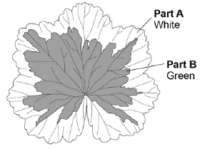
This is the method used.
1. Put the leaf in boiling water for 1 minute.
Reason: stops all chemical reactions in the leaf.
2. Transfer the leaf to boiling ethanol for 5 minutes.
Reason: removes the green colour.
3. Dip the leaf in hot water.
Reason: softens the leaf.
4. Spread the leaf on a white tile and test with iodine solution.
Reason: stains any starch.
(d) If the chemical reactions in the leaf were not stopped, the amount of starch in the leaf would decrease.
Give the reason why.
___________________________________________________________________
___________________________________________________________________
(1)
(e) Suggest why it is important to remove the green colour from the leaf before adding iodine solution.
___________________________________________________________________
___________________________________________________________________
(1)
(f) Ethanol is flammable.
The student wore safety goggles when testing the leaf for starch.
Give one other safety precaution the student should have taken.
___________________________________________________________________
___________________________________________________________________
(1)
(g) Look at the leaf in the diagram.
What colour would part A and part B stain with iodine solution after the starch test?
A ____________________
B ____________________
(2)
(Total 8 marks)
Respiration
Q11.
A man with breathing difficulties goes to hospital.
The photographs below show his lung scan and chest X-ray.
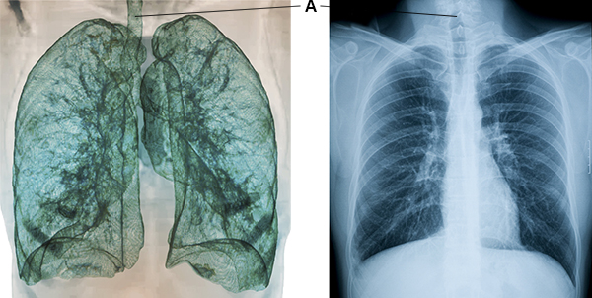
(a) What is part A?
Tick one box.

Bronchus
Capillary
Trachea
Vein
(1)
(b) Give one advantage of using the lung scan, rather than the chest X-ray, to diagnose problems with the man’s breathing system.
___________________________________________________________________
___________________________________________________________________
(1)
(c) Give one advantage of using the chest X-ray, rather than the lung scan, to diagnose problems with the man’s breathing system.
___________________________________________________________________
___________________________________________________________________
(1)
(d) Aerobic respiration and anaerobic respiration are the two types of cell respiration.
Give three differences between aerobic and anaerobic respiration.
1. _________________________________________________________________
___________________________________________________________________
2. _________________________________________________________________
___________________________________________________________________
3. _________________________________________________________________
___________________________________________________________________
(3)
(e) A health website contains the following advice:
Stop smoking and you will be healthier and live longer.
Explain why stopping smoking will improve a person’s health.
___________________________________________________________________
___________________________________________________________________
___________________________________________________________________
___________________________________________________________________
___________________________________________________________________
___________________________________________________________________
___________________________________________________________________
___________________________________________________________________
___________________________________________________________________
___________________________________________________________________
___________________________________________________________________
___________________________________________________________________
___________________________________________________________________
___________________________________________________________________
___________________________________________________________________
(6)
(Total 12 marks)

