Y11 Chemistry 1 PPE Foundation Topic list
The topics below will be assessed in your next PPE

Atomic structure and periodic table
- Group 1 and group 7
- 4.1.3 transition metals

Bonding
- 4.2.1.3 Ionic compounds/properties/structure
- 4.2.1.4- covalent bonding
- 4.2.3 structure and bonding in carbon
- 4.2.4.1 Sizes of particles and their properties

Chemical changes
- RPA- making a salt
- RPA- electrolysis
- 4.4.1.3 Extraction of metals and reduction
- 4.4.2.5 Titrations (chemistry only)- not the method/application

Energy transfer
- RPA- metal powders and acid
- Reaction profiles

Quantitative chemistry
- RFM
- Concentrations of solutions
- Percentage yield

Exam Practice
The following pages contain past exam questions that should attempt.
The grade for each question is indicated by:

Remember: to get Grade 4-5 you still have to be able to answer the 1-3 questions!

Q1.
The halogens are elements in Group 7.
(a) Bromine is in Group 7.
Give the number of electrons in the outer shell of a bromine atom.
_______________________
(1)
(b) Bromine reacts with hydrogen. The gas hydrogen bromide is produced.
What is the structure of hydrogen bromide?
Tick one box.

Giant covalent
Ionic lattice
Metallic structure
Small molecule
(1)
(c) What is the formula for fluorine gas?
Tick one box.

F
F₂
F²
2F
(1)
A student mixes solutions of halogens with solutions of their salts.
The table below shows the student’s observations.

 | Potassium chloride (colourless) | Potassium bromide (colourless) | Potassium iodide (colourless)
Chlorine (colourless) |  | Solution turns orange | Solution turns brown
Bromine (orange) | No change |  | Solution turns brown
Iodine (brown) | No change | No change
(d) Explain how the reactivity of the halogens changes going down Group 7.
Use the results in the table above.
___________________________________________________________________
___________________________________________________________________
___________________________________________________________________
___________________________________________________________________
___________________________________________________________________
___________________________________________________________________
(3)
A company uses chlorine to produce titanium chloride from titanium dioxide.
(e) What is the relative formula mass (M_{r}) of titanium dioxide, TiO₂?
Relative atomic masses (A_{r}): O = 16 Ti = 48
Tick one box.

64
80
128
768
(1)
(f) The company calculates that 500 g of titanium dioxide should produce 1.2 kg of titanium chloride.
However, the company finds that 500 g of titanium dioxide only produces 900 g of titanium chloride.
Calculate the percentage yield.
___________________________________________________________________
___________________________________________________________________
___________________________________________________________________
___________________________________________________________________
Percentage yield = __________________ %
(2)
(Total 9 marks)
Q2.
An atom of aluminium has the symbol
(a) Give the number of protons, neutrons and electrons in this atom of aluminium.
Number of protons _____________________
Number of neutrons _____________________
Number of electrons _____________________
(3)
(b) Why is aluminium positioned in Group 3 of the periodic table?
___________________________________________________________________
___________________________________________________________________
(1)
(c) In the periodic table, the transition elements and Group 1 elements are metals.
Some of the properties of two transition elements and two Group 1 elements are shown in the table below.

 | Transition elements |  | Group 1 elements
 | Chromium | Iron | Sodium | Caesium
Melting point  in °C | 1857 | 1535 | 98 | 29
Formula of  oxides | CrO | FeO | Na₂O | Cs₂O
 | Cr₂O₃ | Fe₂O₃
 | CrO₂ | Fe₃O₄
 | CrO₃
Use your own knowledge and the data in the table above to compare the chemical and physical properties of transition elements and Group 1 elements.
___________________________________________________________________
___________________________________________________________________
___________________________________________________________________
___________________________________________________________________
___________________________________________________________________
___________________________________________________________________
___________________________________________________________________
___________________________________________________________________
___________________________________________________________________
___________________________________________________________________
(6)
(Total 10 marks)
Q3.
This question is about structure and bonding.
(a) Complete the dot and cross diagram to show the covalent bonding in a nitrogen molecule, N₂
Show only the electrons in the outer shell.
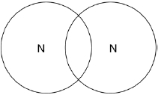
(2)
(b) Explain why nitrogen is a gas at room temperature.
Answer in terms of nitrogen’s structure.
___________________________________________________________________
___________________________________________________________________
___________________________________________________________________
___________________________________________________________________
___________________________________________________________________
___________________________________________________________________
(3)
(c) Graphite and fullerenes are forms of carbon.
Graphite is soft and is a good conductor of electricity.
Explain why graphite has these properties.
Answer in terms of structure and bonding.
___________________________________________________________________
___________________________________________________________________
___________________________________________________________________
___________________________________________________________________
___________________________________________________________________
___________________________________________________________________
___________________________________________________________________
(4)
Q4.
A student makes a hypothesis:
‘When different salt solutions are electrolysed with inert electrodes, the product at the negative electrode is always a metal’.
(a) Describe how you would test this hypothesis in the laboratory.
You should:
• draw a labelled diagram of the apparatus
• give the independent variable
• describe what you would see at the negative electrode if the hypothesis is true.
Diagram

Independent variable _________________________________________________
___________________________________________________________________
Observation _________________________________________________________
___________________________________________________________________
(5)
(b) The student’s hypothesis is only partially correct.
Explain why the product at the negative electrode is not always a metal.
___________________________________________________________________
___________________________________________________________________
(2)
(c) Predict the product at the positive electrode in the electrolysis of:
• sodium chloride solution
• copper sulfate solution.
Sodium chloride solution _______________________________________________
Copper sulfate solution ________________________________________________
(2)
(Total 9 marks)
Q5.
In this question you will be assessed on using good English, organising information clearly and using specialist terms where appropriate.
A student has to check if two samples of hydrochloric acid, A and B, are the same concentration.
Describe how the student could use the apparatus and the solutions in the diagram below to carry out titrations.
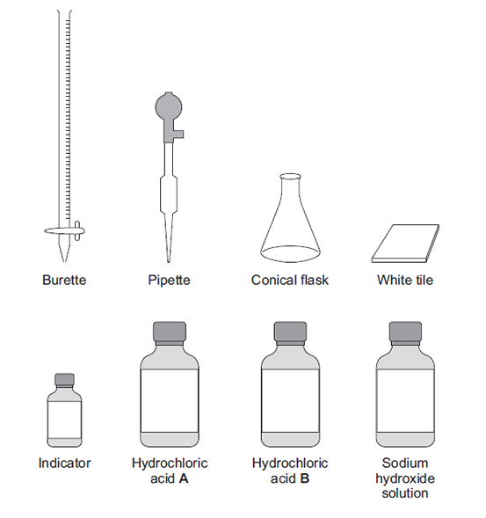
(Total 6 marks)
Q6.
This question is about temperature changes.
(a) A student investigated the temperature change when 8 g of sodium nitrate dissolves in 50 cm³ of water.
The diagram below shows the apparatus the student used.
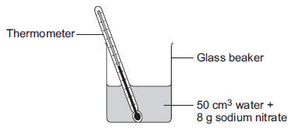
The student did the experiment five times.
Table 1 shows the results.

Table 1
Experiment | Decrease in temperature of water in °C
1 | 5.9
2 | 5.7
3 | 7.2
4 | 5.6
5 | 5.8
(i) Calculate the mean decrease in temperature.
Do not use the anomalous result in your calculation.
______________________________________________________________
______________________________________________________________
Mean decrease in temperature = ___________________ °C
(2)
(ii) Suggest one change in the apparatus in the diagram above which would improve the accuracy of the results.
Give a reason for your answer.
______________________________________________________________
______________________________________________________________
(2)
(b) The student investigated the temperature change when different masses of sodium carbonate were added to 50 cm³ of water at 20 °C.
Table 2 below shows the results.

Table 2
Mass of sodium carbonate in g | Final temperature of solution in °C
2.0 | 21.5
4.0 | 23.0
6.0 | 24.5
8.0 | 26.0
10.0 | 26.6
12.0 | 26.6
14.0 | 26.6
Describe the relationship between the mass of sodium carbonate added and the final temperature of the solution.
Use values from Table 2 in your answer.
___________________________________________________________________
___________________________________________________________________
___________________________________________________________________
___________________________________________________________________
___________________________________________________________________
___________________________________________________________________
(3)
(Total 7 marks)
Q7.
A scientist produces zinc iodide (ZnI₂).
This is the method used.
1. Weigh 0.500 g of iodine.
2. Dissolve the iodine in ethanol.
3. Add an excess of zinc.
4. Stir the mixture until there is no further change.
5. Filter off the excess zinc.
6. Evaporate off the ethanol.
(a) Ethanol is flammable.
Suggest how the scientist could carry out Step 6 safely.
___________________________________________________________________
___________________________________________________________________
(1)
(b) Explain why the scientist adds excess zinc rather than excess iodine.
___________________________________________________________________
___________________________________________________________________
___________________________________________________________________
___________________________________________________________________
___________________________________________________________________
(3)
(c) Calculate the minimum mass of zinc that needs to be added to 0.500 g of iodine so that the iodine fully reacts.
The equation for the reaction is:
Zn + I₂ ⟶ ZnI₂
Relative atomic masses (M_{r}): Zn = 65 I = 127
___________________________________________________________________
___________________________________________________________________
___________________________________________________________________
___________________________________________________________________
___________________________________________________________________
Minimum mass of zinc = ____________________ g
(3)
A different scientist makes zinc iodide by the same method.
The scientist obtains 12.5 g of zinc iodide.
The percentage yield in this reaction is 92.0%.
(d) What is the maximum theoretical mass of zinc iodide produced in this reaction?
___________________________________________________________________
___________________________________________________________________
___________________________________________________________________
___________________________________________________________________
___________________________________________________________________
___________________________________________________________________
Maximum theoretical mass = ____________________ g
(3)
(e) Suggest one reason why the percentage yield in this reaction is not 100%.
___________________________________________________________________
___________________________________________________________________
(1)
(f) The scientist makes a solution of zinc iodide with a concentration of 0.100 mol / dm³
Calculate the mass of zinc iodide (ZnI₂) required to make 250 cm³ of this solution.
Relative atomic masses (A_{r}): Zn = 65 I = 127
___________________________________________________________________
___________________________________________________________________
___________________________________________________________________
___________________________________________________________________
___________________________________________________________________
___________________________________________________________________
Mass = ____________________ g
(3)
(Total 14 marks)

