Y11 Combined Biology 1
PPE 2 - Foundation
For each topic, there are questions in the Revision Guide that will help you choose what to revise. The page numbers you need are listed below.
Topic | Questions  Page Title |  | Support  Pages
Eukaryotic and prokaryotic cells | 23 | Cells and microscopy | 11
Microscopy | 23 |  | 12-13
Osmosis | 23 | Exchanging substances | 18
Stem cells | 23 | Stem cells | 16
Coronary heart disease | 41 | Diseases and risk factors | 30-34
Plant disease | 56 | Types of disease | 42-45
Discovery of drugs | 56 | Fighting disease | 48-49
Response to exercise | 56 | Respiration and metabolism | 53-54

Exam Practice
The following pages contain past exam questions that should attempt.
The grade for each question is indicated by:

Remember: to get Grade 4-5 you still have to be able to answer the 1-3 questions!

Biology 1 Checklist
PPE 2 - Foundation

What you need to know and be able to do.
Once you feel confident with a topic, tick the box to show that you have revised this. You will still need to keep going over it though!

Cells
- Describe the structure and function of animal and bacterial cells
- Describe the structure and function of plant cells
- Calculate magnification
- RPA- osmosis. Interpret secondary data on the RPA osmosis
- Describe types of cell division
- Know what a stem cell is
- Evaluate the use of stem cells in medicine

Organisation
- Describe the structure of the heart
- Describe ways to treat CHD
- Interpret data on causes of CHD

Infectious disease
- Describe types of plant disease- how they spread and how they can be treated
- Apply knowledge to interpret data and information on drug testing.

4/6 Mark Questions  All science papers will contain at least one extended writing question.  These will be either 4 or 6 marks.  The criteria for each type of question is always the same.  This page shows you the criteria for reaching each level on a 6 mark question based on the command word. | Design/Plan  Level 3: The design/plan would lead to the production of a valid outcome. All key steps are identified and logically sequenced.  Level 2: The design/plan would not necessarily lead to a valid outcome. Most steps are identified, but the plan is not fully logically sequenced.  Level 1: The design/plan would not lead to a valid outcome. Some relevant steps are identified, but links are not made clear.
Compare  Level 2: Scientifically relevant features are identified: the way(s) in which they are similar/different is made clear and (where appropriate) the magnitude of the similarity/difference is noted.  Level 1: Relevant features are identified and differences noted.  No relevant content | Evaluate  Level 3: A judgement, strongly linked and logically supported by a sufficient range of correct reasons, is given  Level 2: Some logically linked reasons are given. There may also be a simple judgement.  Level 1: Relevant points are made. They are not logically linked.
Describe  Level 2: Scientifically relevant facts, events or processes are identified and given in detail to form an accurate account.  Level 1: Facts, events or processes are identified and simply stated but their relevance is not clear.  No relevant content | Explain  Level 3: Relevant points (reason/causes) are identified, given in detail and logically linked to form a clear account.  Level 2: Relevant points (reason/causes) are identified, and there are attempts at logical linking. The resulting account is not fully clear.  Level 1: Points are identified and stated simply, but the relevant is not clear and there is no attempt at logical linking.

Cell Biology- Eukaryotic and prokaryotic cells
Q1.
Living organisms are made of cells.
(a) Animal and plant cells have several parts. Each part has a different function.
Draw one line from each cell part to the correct function of that part.
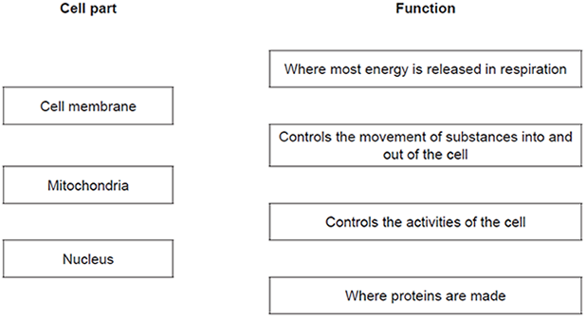
(3)
(b) The diagram below shows a cell from a plant leaf.
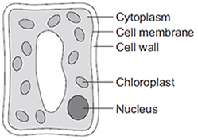
Which two parts in the diagram above are not found in an animal cell?
1. _________________________________________________________________
2. _________________________________________________________________
(2)
(Total 5 marks)
Cell Biology - Stem cells
Q2.
The diagram shows how cells from human embryos can be used to grow ‘replacement body parts’ for humans.
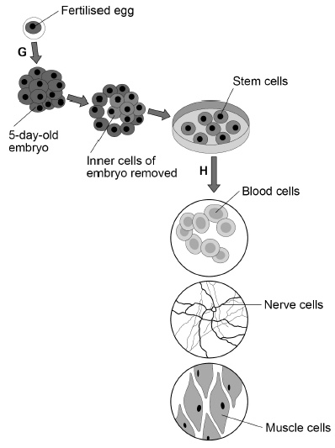
(a) How many chromosomes are in a fertilised human egg?
Tick one box.

12 |  | 23 |  | 46 |  | 92
(1)

(b) What is the process labelled G?
Tick one box.

Fertilisation
Inheritance
Meiosis
Mitosis
(1)
(c) When the embryo is three days old, it contains eight cells.
How many times has the fertilised egg cell divided by day three?
Tick one box.

2 |  | 3 |  | 4 |  | 8
(1)
(d) Stem cells become specialised in the process labelled H in the diagram.
What is the process labelled H?
Tick one box.

Differentiation
Evolution
Genetic modification
Selective breeding
(1)

(e) Which two parts would be found in all the cells in the diagram.
Tick two boxes.

Cell membrane
Cell wall
Chloroplasts
Cytoplasm
Plasmids
(2)
(f) Why might stem cells from human embryos be more useful than stem cells from adults?
___________________________________________________________________
___________________________________________________________________
(1)
(g) Some parents have stem cells from the umbilical cord of their baby collected and stored.
These stem cells can be used to treat diseases in the child later in life.
Why might stem cells from their own umbilical cord be used rather than stem cells from another embryo?
Tick one box.

Less risk of rejection of umbilical cord stem cells.
Stem cells from another embryo can treat more diseases.
Umbilical cord stem cells are older.
(1)
(h) Some medical uses of stem cells are still experimental.
Why do some scientists have concerns about the use of stem cells?
___________________________________________________________________
___________________________________________________________________
(1)

(i) Some people object to the use of embryonic stem cells because of religious beliefs.
Give one other ethical concern about the use of embryonic stem cells?
___________________________________________________________________
___________________________________________________________________
(1)
(Total 10 marks)
Organisation - Coronary heart disease
Q3.
Obesity is a factor that affects Coronary Heart Disease (CHD).
(a) What is meant by obesity?
___________________________________________________________________
___________________________________________________________________
(1)
(b) The graph shows how the percentages of obese men and women in the UK changed between 1994 and 2004.
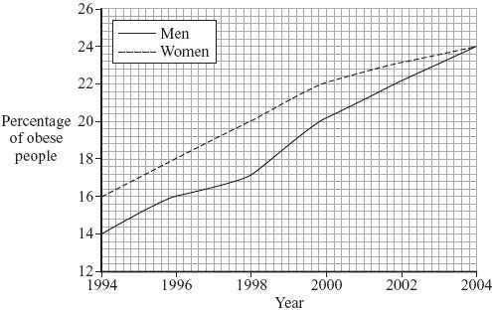
(i) Describe how the percentage of obese women changed between 1994 and 2004.
______________________________________________________________
______________________________________________________________
______________________________________________________________
______________________________________________________________
(2)
(ii) The percentage of obese men changed between 1994 and 2004.
Suggest two reasons for this change.
1. ____________________________________________________________
______________________________________________________________
2. ____________________________________________________________
______________________________________________________________
(2)
(c) The chart below is published by the British Heart Foundation. It shows how death from CHD is related to a number of different factors.
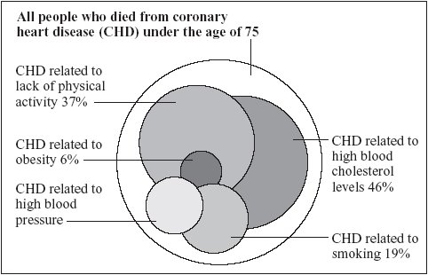
copyright National Heart Forum
Each factor is represented by a circle.
The bigger the circle, the more people are affected by the factor.
(i) What is the main factor causing death from CHD?
______________________________________________________________
(1)
(ii) Estimate the percentage of deaths from CHD related to high blood pressure.
_________________________ %
(1)

(iii) The data are shown as overlapping circles instead of a bar chart. The percentages of deaths related to the different factors add up to more than 100%.
What does this tell you about some of the people who died from CHD?
______________________________________________________________
______________________________________________________________
(1)
(Total 8 marks)

Bioenergetics- Response to exercise
Q4.
An athlete did a 6-month training programme.
The graph shows the effect of the same amount of exercise on his heart rate before and after the training programme.
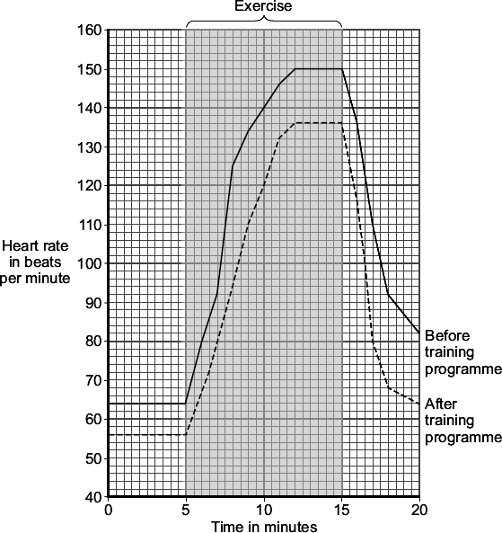
(a) (i) What was the maximum heart rate of the athlete during exercise before the training programme?
_________________________ beats per minute
(1)

(ii) Give two differences between the heart rate of the athlete before and after the training programme.
After the training programme
Difference 1 ____________________________________________________
______________________________________________________________
Difference 2 ____________________________________________________
______________________________________________________________
(2)
(b) Which two substances need to be supplied to the muscles in larger amounts during exercise?
Tick () two boxes.

Carbon dioxide
Glucose
Lactic acid
Oxygen
Urea
(2)
(Total 5 marks)

Required Practical Activity- Osmosis G4
Q5.
Osmosis is the movement of water through partially permeable cell membranes.
A group of students investigated the effect of temperature on the rate of osmosis in potato cells. The students used five potato chips all cut to the same size.
Figure 1 shows one chip.
Figure 1
This is the method used.
1. Half fill a boiling tube with distilled water.
2. Heat the water to 25 °C
3. Place one potato chip in the boiling tube.
4. Keep the boiling tube and potato chip at 25 °C for 30 minutes.
5. Repeat steps 1−4 at four other temperatures.
(a) All of the potato chips gained water by osmosis.
Explain how the students would find out the rate of water uptake by osmosis in each potato chip.
___________________________________________________________________
___________________________________________________________________
___________________________________________________________________
___________________________________________________________________
___________________________________________________________________
___________________________________________________________________
(3)
(b) One of the students used a knife to cut the potato chips.
Suggest how the student could improve the method of cutting the potato chips to make sure they are all the same size.
___________________________________________________________________
___________________________________________________________________
(1)

(c) Another student cut their potato chips as shown in Figure 2.
Figure 2
Suggest how the rate of water uptake by osmosis in this investigation was different from the investigation with the chips shown in Figure 2.
Give a reason for your answer.
___________________________________________________________________
___________________________________________________________________
___________________________________________________________________
___________________________________________________________________
(2)
(d) The students carried out the experiment at 25 °C, 30 °C, 35 °C, 40 °C and 45 °C
Predict what you would expect the results to show as the temperature increases.
Give a reason for your answer.
Prediction __________________________________________________________
___________________________________________________________________
Reason ____________________________________________________________
___________________________________________________________________
(2)
(Total 8 marks)

Infectious disease - Drug testing
Q6.
Obesity is linked to several diseases.
(a) Name two diseases linked to obesity.
1. _________________________________________________________________
2. _________________________________________________________________
(2)
(b) Scientists trialled a new slimming drug.
The table shows their results after one year.

Percentage change in mass  of each volunteer | Number of volunteers
gained mass or lost 0 to 3.9 % | 1900
lost 4.0 to 4.9 % | 1100
lost 5.0 to 9.9 % | 1500
lost 10 % or more | 1500
(i) Calculate the proportion of the volunteers who lost 10 % or more of their mass.
You should first calculate the total number of volunteers, then work out the proportion.
______________________________________________________________
______________________________________________________________
Proportion of volunteers = _________________________
(2)
(ii) The National Health Service (NHS) gave permission for the drug to be used.
Use information from the table to suggest a reason why the NHS gave permission for the drug to be used.
______________________________________________________________
______________________________________________________________
(1)
(Total 5 marks)

Required practical Activity - Microscopy
Q7.
This question is about cell structures.
(a) Draw one line from each cell structure to the type of cell where the structure is found.

Cell Structure |  | Type of cell where the structure is found
Nucleus |  | Prokaryotic cells
Permanent vacuole |  | Plant cells only
Plasmid |  | Eukaryotic cells
(2)
(b) Figure 1 shows a plant cell.
Figure 1
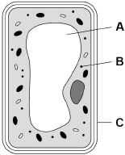
What are the names of structures A, B and C?
Tick one box.

Structure A | Structure B | Structure C
Chloroplast | Vacuole | Cell wall
Nucleus | Chloroplast | Cell membrane
Vacuole | Mitochondrion | Cell membrane
Vacuole | Ribosome | Cell wall
(1)
A student observed slides of onion cells using a microscope.
Figure 2 shows two of the slides the student observed.
Figure 2
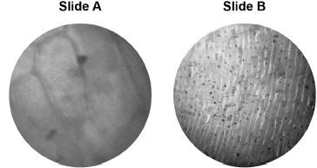
The cells on the slides are not clear to see.
(c) Describe how the student should adjust the microscope to see the cells on Slide A more clearly.
___________________________________________________________________
___________________________________________________________________
(1)
(d) Describe how the student should adjust the microscope to see the cells on Slide B more clearly.
___________________________________________________________________
___________________________________________________________________
___________________________________________________________________
(2)
(e) The student made the necessary adjustments to get a clear image.
Figure 3 shows the student’s drawing of one of the cells.
Figure 3
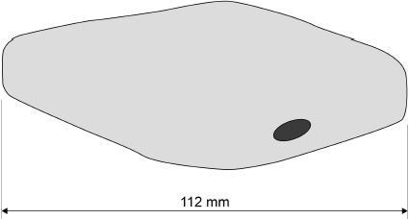
The real length of the cell was 280 micrometres (µm).
Calculate the magnification of the drawing.
___________________________________________________________________
___________________________________________________________________
___________________________________________________________________
___________________________________________________________________
___________________________________________________________________
Magnification = × _________________________
(3)
(Total 9 marks)

