Y11 Combined Physics 1
PPE 2 - Foundation
The topics below will be assessed in your next PPE
Energy
- RPA – Specific heat capacity
- Efficiency
- National and global resources
  - evaluate renewable and non-renewable energy

Electricity
- RPA – Resistance in wires/filament lamps
- National grid – Transformers
- Series and parallel circuits

Particles
- Particle motion in gases

Atomic structure
- Nuclear equations
- Radioactive contamination

Exam Practice
The following pages contain past exam questions that should attempt.
The grade for each question is indicated by:

Remember: to get Grade 4-5 you still have to be able to answer the 1-3 questions!

Use your revision guide to help you answer the questions in this booklet.

The revision guide also has extra questions you can complete.
For each topic, there are questions in the Revision Guide that will help you choose what to revise. The page numbers you need are listed below.
Topic | Questions  Page Title |  | Support  Pages
RPA: Specific heat capacity | 192 | Specific Heat Capacity | 171
Efficiency | 192 | Power and Efficiency | 172-174
National and global resources | 192 | Energy Resources and Trends in their Use | 175-179
Resistance in wires | 192 | Circuit Basics | 180-187
National Grid | 192 | Power and the National Grid | 189-191
Series and parallel circuits | 192 | Circuit Basics | 180-187
Particle motion in gases | 202 | The Particle Model and Motion in Gases | 193
Nuclear equations | 202 | Nuclear Decay and Half-life | 198-200
Radioactive contamination | 202 | Irradiation and Contamination | 201

Energy
Q1.
Different energy sources are used to generate electricity.
(a) Use words from the box to match the correct energy source to each of the descriptions given in the table.

biofuel | coal | geothermal | nuclear | waves

Description | Energy source
Energy from the Earth’s core is used to heat water.
Fission of uranium nuclei is used to heat water.
Gases from rotting plant material are burned to heat water.
(3)
(b) Energy can be stored in a pumped storage power station.
The figure shows a pumped storage power station.
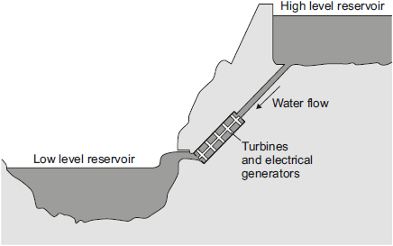
When electricity is needed, the water in the high level reservoir is allowed to flow to the low level reservoir. The flowing water generates electricity.
Use the correct answer from the box to complete each sentence.

electrical | gravitational potential | kinetic | nuclear | sound
The water in the high level reservoir stores ____________ energy.
The flowing water has ____________ energy.
The water turns the turbine which is connected to the generator.
The generator produces some ____________, this is wasted energy.
(3)
(c) The total power input to a pumped storage power station is 600 MW.
The useful power output is 540 MW.
(i) Calculate the efficiency of this pumped storage power station.
______________________________________________________________
______________________________________________________________
______________________________________________________________
Efficiency = _______________
(2)
(ii) Calculate how much power is wasted by the pumped storage power station.
______________________________________________________________
Power = ______________ MW
(1)
(iii) How is the temperature of the surroundings affected by the energy wasted by the pumped storage power station?
______________________________________________________________
(1)
(Total 10 marks)
Energy
Q2.
Iceland is a country that generates most of its electricity using geothermal power stations and hydroelectric power stations.
(a) (i) Complete the following sentences to describe how some geothermal power stations work.
In regions where volcanoes are active, the ground is hot.
Cold _______________________ is pumped down into the ground
and is _______________________ by hot rocks.
It returns to the surface as steam. The steam is used to turn a turbine.
The turbine drives a _______________________ to produce electricity.
(3)
(ii) Which one of the following statements about geothermal power stations is true?
Tick () one box.
Geothermal power stations use fossil fuels.
Geothermal power stations produce carbon dioxide.
Geothermal power stations provide a reliable source of electricity.
(1)
(b) What is needed for a hydroelectric power station to be able to generate electricity?
Tick () one box.
Falling water
A long coastline
Lots of sunny days
(1)
(Total 5 marks)

National Grid
Q3.
The diagram shows how electricity is generated, and transmitted by the National Grid.
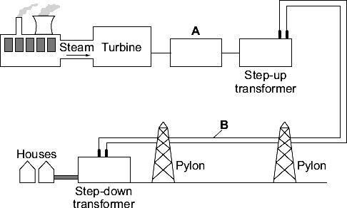
(a) Name the parts labelled A and B.
(i) Part A _____________________________________________
(1)
(ii) Part B _____________________________________________
(1)
(b) The step-up transformer makes changes to the electricity supplied by the power station.
Use words from the box to complete each sentence.

current | energy | power | voltage
The step-up transformer increases the _______________________ of the supply.
The step-up transformer decreases the _______________________ of the supply.
(2)
(c) Information about five different types of power stations is given in the table.

Power station | Start-up time | Power output in MW
Biomass | Medium | 20
Geothermal | Medium | 30
Nuclear | Long | 1200
Hydroelectric | Short | 2000
Wind turbine | Short | 5
(i) Which power station would be best to meet peak demands for electricity?
______________________________________________________________
(1)
(ii) Which power station uses a non-renewable energy resource?
______________________________________________________________
(1)
(iii) Wind turbines are used to generate electricity.
Give one advantage and one disadvantage of using wind turbines to generate electricity.
Advantage _____________________________________________________
______________________________________________________________
Disadvantage ___________________________________________________
______________________________________________________________
(2)
(Total 8 marks)
Series and parallel circuits
Q4.
Figure 1 shows the circuit symbol for three different components.
Figure 1
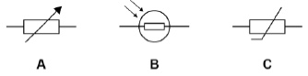
(a) Which component is a variable resistor?
Tick one box.

A |  | B |  | C
(1)
(b) Which component is a thermistor?
Tick one box.

A |  | B |  | C
(1)
(c) In which component will the resistance decrease when the temperature increases?
Tick one box.

A |  | B |  | C
(1)
(d) In which component will the resistance decrease when the light intensity increases?
Tick one box.

A |  | B |  | C
(1)
Figure 2 shows four different arrangements of resistors.
Figure 2
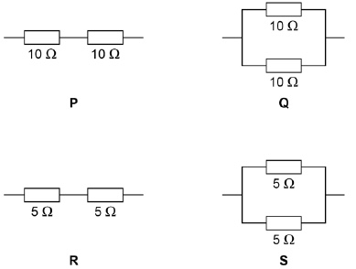
(e) Two of the arrangements are in series and two are in parallel.
Describe the difference between a series and a parallel arrangement.
___________________________________________________________________
___________________________________________________________________
___________________________________________________________________
___________________________________________________________________
(2)
(f) Which arrangement has a resistance of 10 Ω?
Tick one box.

P |  | Q |  | R |  | S
(1)
(g) Which arrangement has the highest resistance?
Tick one box.

P |  | Q |  | R |  | S
(1)
(h) A student connects a resistor to a cell for 60 seconds.
The current through the resistor is 0.97 A
Calculate the charge flow.
Use the equation:
charge flow = current × time
Give your answer to 2 significant figures.
___________________________________________________________________
___________________________________________________________________
___________________________________________________________________
___________________________________________________________________
___________________________________________________________________
___________________________________________________________________
Charge flow = ____________________ C
(3)
(Total 11 marks)
Particle theory
Q5.
The diagram shows a model of the particles in a gas and in a liquid.
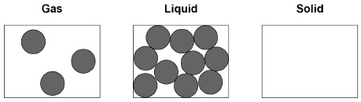
(a) Complete the diagram to show the arrangement of particles of the same substance as a solid.
(2)
(b) What is the name of the process when a substance changes from a gas to a liquid?
Tick one box.

Condensing
Evaporating
Freezing
Melting
(1)
(c) The substance in the diagram has a:
• melting point of 98 °C
• boiling point of 883 °C
What is the state of the substance at 20 °C?
Tick one box.

Gas |  | Liquid |  | Solid
(1)
(d) What type of change is a change of state?
Tick one box.

Chemical
Kinetic
Permanent
Physical
(1)
(e) Which two statements are correct about the particles when a liquid turns into a gas?
Tick two boxes.

Particles are bigger
Particles are lighter
Particles have more chemical energy
Particles have more kinetic energy
Particles move faster
(2)
(f) Which two quantities are needed to calculate the energy required to turn a liquid into a gas with no change in temperature?
Tick two boxes.

Mass of the liquid
Specific heat capacity of the gas
Specific latent heat of vaporisation
Time the liquid is heated
(2)
Specific heat capacity
(g) A mass of 2.0 kg of water is heated.
The temperature increase of the water is 80 °C
The specific heat capacity of water is 4200 J / kg °C
Calculate the change in thermal energy when the water is heated.
Use the equation:
change in thermal energy = mass × specific heat capacity × temperature change
___________________________________________________________________
___________________________________________________________________
___________________________________________________________________
Change in thermal energy = ____________________ J
(2)
(Total 11 marks)

Atomic structure
Q6.
Before using a radioactive source, a teacher asked her students to suggest safety procedures that would reduce her exposure to the radiation. The students made the following
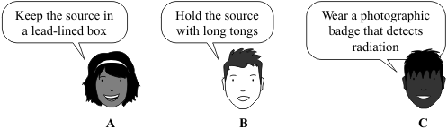
(a) Which suggestion, A, B or C, would not reduce the exposure of the teacher to radiation?
____________________________________
(1)
(b) The diagram shows how the teacher measured the distance that the radiation traveled from the source. The count-rate at different distances from the source was measured and recorded in the table.
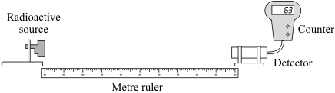

Distance from source to detector in cm | Count-rate in counts per minute
20 | 85
40 | 81
60 | 58
80 | 53
100 | 23
What type of radiation was the source emitting, alpha, beta or gamma?
___________________________________________________________________

Explain the reasons for your choice.
___________________________________________________________________
___________________________________________________________________
___________________________________________________________________
___________________________________________________________________
(3)
(c) The graphs show how two groups of scientists, A and B, link exposure to radiation and the risk of getting cancer.
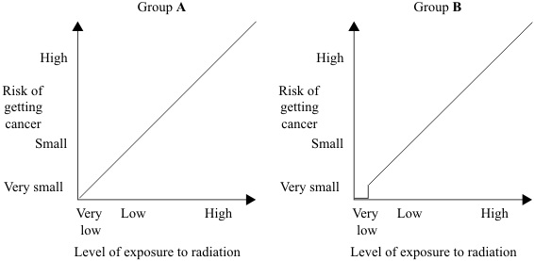
(i) Complete the following sentence using a word or phrase from the box.

decreases has no effect on increases
Both groups of scientists agree that a high level of exposure to radiation
______________________________ the risk of getting cancer.
(1)
(ii) Use the graphs to describe carefully how the two groups of scientists disagree when the level of exposure to radiation is very low.
______________________________________________________________
______________________________________________________________
______________________________________________________________
______________________________________________________________
(2)
(Total 7 marks)

Atomic structure
Q7.
(a) The diagram represents 3 atoms, K, L and M.
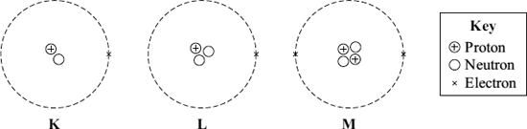
(i) Which two of the atoms are isotopes of the same element?
__________ and __________
(1)
(ii) Give a reason why the two atoms that you chose in part (a)(i) are:
(1) atoms of the same element ____________________________________
______________________________________________________________
(2) different isotopes of the same element. ___________________________
______________________________________________________________
______________________________________________________________
(2)
(b) The table gives some information about the radioactive isotope thorium-230.

mass number | 230
atomic number | 90
(i) How many electrons are there in an atom of thorium-230?
_________________________
(1)
(ii) How many neutrons are there in an atom of thorium-230?
_________________________
(1)
(c) When a thorium-230 nucleus decays, it emits radiation and changes into radium-226.
What type of radiation, alpha, beta or gamma, is emitted by thorium-230?
_________________________
Explain the reason for your answer.
___________________________________________________________________
___________________________________________________________________
___________________________________________________________________
___________________________________________________________________
___________________________________________________________________
(3)
(Total 8 marks)

