Y11 Combined Chemistry 1
PPE 2 - Foundation
For each topic, there are questions in the Revision Guide that will help you choose what to revise. The page numbers you need are listed below.
Topic | Questions  Page Title |  | Support  Pages
A simple model of the atom | 112 | Atoms, Elements and Compounds | 96-99
Group 7 | 112 | Groups of the Periodic Table | 107-111
Ionic compounds | 127 | Ions and Ionic Compounds | 113-115
Covalent compounds (Graphite) | 127 | Covalent substances | 116-119
Metallic bonding | 127 | Metallic Bonding | 120
Concentrations of solutions | 127 | Concentrations of Solutions | 126
RPA – Making a salt | 137 | Acids and their reactions | 129
pH and neutralisation | 137 | Acids and their reactions | 128-129
Electrolysis | 137 | Electrolysis | 132-133
RPA – Energy transfer | 137 | Exothermic and Endothermic Reactions | 135

Exam Practice
The following pages contain past exam questions that should attempt.
The grade for each question is indicated by:

Remember: to get Grade 4-5 you still have to be able to answer the 1-3 questions!

Atomic structure
Q1.
The table below shows the relative mass and charge of the particles in an atom.

Name of particle | Relative mass | Charge
proton | 1 | +1
neutron
electron | very small
(a) Complete the table above.
(3)
(b) The diagram below represents a lithium atom.
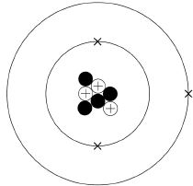
Give the number of protons, neutrons and electrons in the lithium atom shown in the diagram above.
Number of protons _________________
Number of neutrons _________________
Number of electrons _________________
(3)

(c) Scientific models of the atom have changed over time.
Draw one line from each description of the atomic model to the stage in the development of the atomic model.

Description of atomic model |  | Stage in the development of the atomic model
 |  | Dalton atoms
A ball of positive charge with electrons embedded in it
 |  | Neutrons discovered
 |  | Nucleus of atoms discovered
Spherical atoms
 |  | Plum pudding model
(2)
(Total 8 marks)
Halogens
Q2.
This question is about the halogens.
(a) Which group in the periodic table is known as the halogens?
Tick one box.

Group 1
Group 2
Group 7
Group 0
(1)

Covalent Bonding
(b) A fluorine atom has 7 electrons in the outer shell.
The diagram below shows part of a dot and cross diagram to represent a molecule of fluorine (F₂).
Complete the dot and cross diagram.
You should show only the electrons in the outer shells.
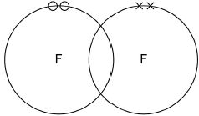
(2)
(c) Chlorine reacts with potassium bromide solution.
Complete the word equation.
potassium _________________
chlorine + bromide ⟶ _________________ +
_________________
(2)
(d) What type of reaction happens when chlorine reacts with potassium bromide solution?
Tick one box.

decomposition
displacement
neutralisation
precipitation
(1)

Properties of covalent molecules
(e) Complete the sentence.
Choose the answer from the box.

an atom | an electron | a neutron | a proton
Chlorine is more reactive than bromine.
This is because chlorine gains ________________________________ more easily.
(1)
(f) How does the size of a chlorine atom compare with the size of a bromine atom?
Complete the sentence.
Choose the answer from the box.

bigger than | the same size as | smaller than
A chlorine atom is ______________________________________ a bromine atom.
(1)
(g) Give a reason for your answer to part (f)
Reason ____________________________________________________________
___________________________________________________________________
(1)
(h) Fluorine reacts with chlorine to produce ClF₃
Balance the chemical equation for the reaction.
Cl₂ + ________F₂ ⟶ 2 ClF₃
(1)

Properties of covalent molecules- Extended writing
(i) Explain why fluorine is a gas at room temperature.
Use the following words in your answer:
energy forces molecules weak
___________________________________________________________________
___________________________________________________________________
___________________________________________________________________
___________________________________________________________________
___________________________________________________________________
___________________________________________________________________
___________________________________________________________________
___________________________________________________________________
___________________________________________________________________
___________________________________________________________________
___________________________________________________________________
___________________________________________________________________
___________________________________________________________________
(3)
(Total 13 marks)

Ionic bonding and properties
Q3.

The drawing shows a container of a compound called magnesium chloride.
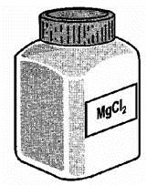
(i) How many elements are joined together to form magnesium chloride?
___________________________________________________________________
(1)
(ii) Magnesium chloride is an ionic compound. What are the names of its ions?
_________________________ ions and _________________________ ions
(1)
(iii) How many negative ions are there in the formula for magnesium chloride?
___________________________________________________________________
(1)
(iv) Complete the sentence.
Ions are atoms, or groups of atoms, which have lost or gained
_____________________ .
(1)

(v) Suggest three properties which magnesium chloride has because it is an ionic compound.
Property 1 __________________________________________________________
___________________________________________________________________
Property 2 __________________________________________________________
___________________________________________________________________
Property 3 __________________________________________________________
___________________________________________________________________
(3)
(Total 7 marks)
Quantitative chemistry
Q4.
Figure 1 shows a reactor used to produce titanium from titanium(IV) chloride.
Figure 1
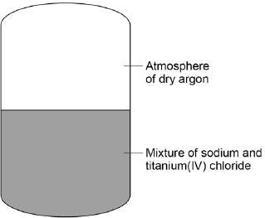
The chemical equation for the reaction of titanium(IV) chloride with sodium is:
TiCl₄ + 4Na Ti + 4NaCl
titanium(IV) chloride + sodium titanium + sodium chloride
(a) For one reaction:
• 1615 kg titanium(IV) chloride reacted completely with 782 kg sodium
• 1989 kg sodium chloride was produced.
Calculate the mass of titanium produced from this reaction.
___________________________________________________________________
___________________________________________________________________
Mass of titanium = _________________ kg
(1)
(b) The table below shows the solubility of sodium chloride in 100 cm³ of aqueous solution at different temperatures.

Solubility of sodium chloride in g per 100cm³ | Temperature in °C
35.72 | 10
35.89 | 20
36.09 | 30
37.37 | 40
36.69 | 50
37.04 | 60
On Figure 2:
• plot this data on the grid
• draw a line of best fit.
Figure 2
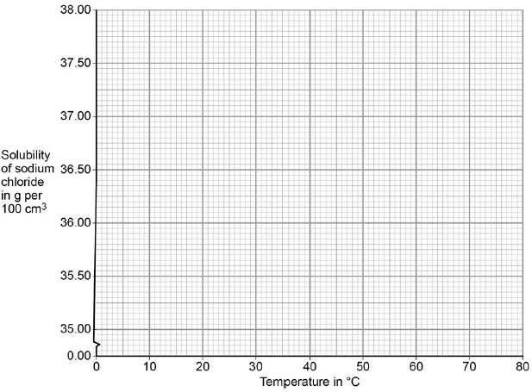
(3)

(c) The product sodium chloride is dissolved in water to separate it from titanium.
At 30 °C the solubility of sodium chloride is 36 kg per 100 dm³.
Calculate the minimum volume of water in dm³, at 30 °C, needed to dissolve 1989 kg sodium chloride.
___________________________________________________________________
___________________________________________________________________
___________________________________________________________________
___________________________________________________________________
Volume of water = ____________________ dm³
(2)
(d) Calculate the percentage by mass of titanium in titanium(IV) chloride (TiCl₄).
Give your answer to 3 significant figures.
Relative atomic masses (A_{r}): Cl = 35.5; Ti = 48
___________________________________________________________________
___________________________________________________________________
___________________________________________________________________
Percentage of titanium by mass = _______________ %
(3)
(e) Suggest why the reaction is done in an atmosphere of dry argon instead of air containing water vapour.
___________________________________________________________________
___________________________________________________________________
___________________________________________________________________
___________________________________________________________________
___________________________________________________________________
___________________________________________________________________
(3)

Properties of metals
(f) Explain why titanium conducts electricity.
___________________________________________________________________
___________________________________________________________________
___________________________________________________________________
___________________________________________________________________
___________________________________________________________________
___________________________________________________________________
(3)
(Total 15 marks)
pH and neutralisation
Q5.
The pH scale is a measure of the acidity or alkalinity of a solution.
(a) Draw one line from each solution to the pH value of the solution.

Solution |  | pH value of the solution

 |  | 5
Acid |  | 7
 |  | 9
Neutral |  | 11
 |  | 13
(2)
(b) Which ion in aqueous solution causes acidity?
Tick one box.

H⁺
Na⁺
O²⁻
OH⁻
(1)

(c) When sulfuric acid is added to sodium hydroxide a reaction occurs to produce two products.
The equation is:
H₂SO₄ + 2NaOH Na₂SO₄ + 2H₂O
How many elements are in the formula H₂SO₄?
Tick one box.

3
4
6
7
(1)
(d) What is this type of reaction?
Tick one box.

Decomposition
Displacement
Neutralisation
Reduction
(1)
(e) Name the salt produced.
___________________________________________________________________
(1)
(f) Describe how an indicator can be used to show when all the sodium hydroxide has reacted with sulfuric acid.
___________________________________________________________________
___________________________________________________________________
___________________________________________________________________
___________________________________________________________________
___________________________________________________________________
___________________________________________________________________
(3)
(Total 9 marks)

Electrolysis
Q6.
This question is about the electrolysis of two compounds.
Figure 1 shows the electrolysis of molten lead bromide.
Figure 1
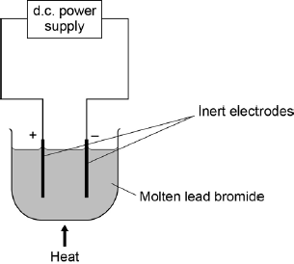
(a) The electrolyte contains lead ions (Pb²⁺) and bromide ions (Br–).
Complete the sentences.
Use words from the box.

atoms bromide bromine ions
lead molecules oxygen
At the positive electrode the gas produced is_________________________
At the negative electrode lead ____________________________________
gain electrons and ___________________ .
(3)

(b) A student measured the volumes of each gas produced during the electrolysis of water.
The table below shows the student’s results.

Time in minutes | Volume of gas produced in cm³
 | Hydrogen | Oxygen
0 | 0 | 0
2 | 11.2 | 5.4
4 | 20.1 | 11.4
6 | 32.5 | 17.6
8 | 40.0 | 23.7
10 | 60.9 | 30.0
The student plotted a graph of the results for oxygen. Figure 2 shows the graph.
The student did not put a scale on the y axis.
On the graph in Figure 2:
• complete the scale for the y axis
• plot the results for hydrogen
• include a line of best fit.
Figure 2
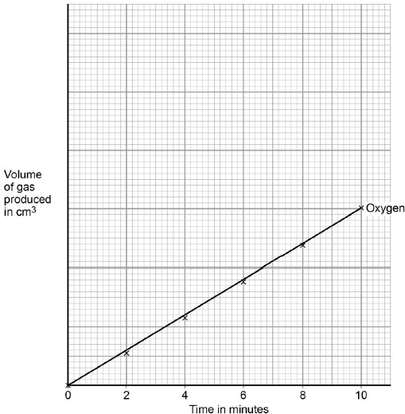
(3)
(c) Use the graph to calculate the mean volume of oxygen produced per second.
___________________________________________________________________
___________________________________________________________________
___________________________________________________________________
___________________________________________________________________
Mean volume of oxygen produced = __________ cm³ / s
(3)
(Total 9 marks)

Required Practical Activity- Making a salt
Q7.
This question is about making copper salts.
The figure below shows the apparatus given to a student.
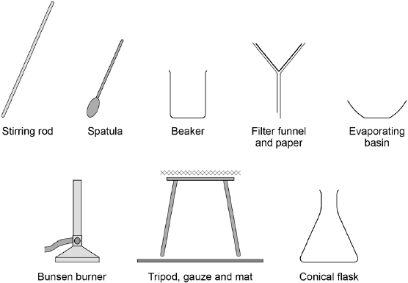
Outline a safe plan the student could use to make pure, dry, crystals of the soluble salt copper sulfate from the insoluble metal oxide and dilute acid.
_______________________________________________________________________
_______________________________________________________________________
_______________________________________________________________________
_______________________________________________________________________
_______________________________________________________________________
_______________________________________________________________________
_______________________________________________________________________
_______________________________________________________________________
_______________________________________________________________________
_______________________________________________________________________
(Total 6 marks)
Required practical activity- Energy transfer
Q8.
Some students investigated the reactivity of four unknown metals, W, X, Y and Z.
The letters are not the symbols of these elements.
The students used metal salt solutions of copper nitrate, magnesium sulfate and zinc chloride.
This is the method used.
1. Pour a solution of a metal salt into a glass beaker.
2. Measure the temperature of the solution.
3. Add 1 g of metal to the solution.
4. Measure the temperature of the solution.
5. Calculate the temperature increase.
The students did the experiment using each salt solution with each metal.
Figure 1 shows the apparatus the students used.
Figure 1
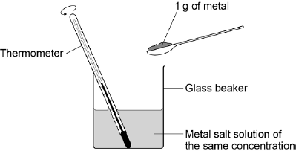
The table below shows the students’ results.

 | Temperature increase in °C
Solution | Metal W | Metal X | Metal Y | Metal Z
Copper nitrate | 46 | 10 | 29 | No change
Magnesium sulfate | No change | No change | No change | No change
Zinc chloride | 15 | No change | No change | No change

(a) Which metal is least reactive?
Tick one box.

Metal W
Metal X
Metal Y
Metal Z
(1)
(b) How do the results show that magnesium is more reactive than the metals W, X, Y and Z?
___________________________________________________________________
___________________________________________________________________
(1)
(c) How do the results show that the reaction between metal Y and copper nitrate solution is exothermic?
___________________________________________________________________
___________________________________________________________________
(1)
(d) One student said that the investigation was not valid (a fair test).
Write a plan for the investigation that includes improvements to the method and apparatus.
___________________________________________________________________
___________________________________________________________________
___________________________________________________________________
___________________________________________________________________
___________________________________________________________________
___________________________________________________________________
___________________________________________________________________
___________________________________________________________________
(4)

Reaction profiles
(e) Figure 2 shows the reaction profile of an exothermic reaction.
Figure 2
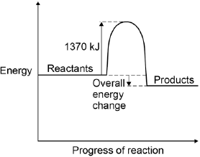
What does the energy value of 1370 kJ represent?
Tick one box.

Activation energy
Products energy
Reactants energy
Released energy
(1)
(f) The overall energy change is 386 kJ.
What percentage of 1370 kJ is this?
Give your answer to two significant figures.
___________________________________________________________________
Percentage = ___________________ %
(2)
(Total 10 marks)

Mark schemes
Q1.
(a)
name of particle | relative mass | charge
proton | (1) | (+1)
neutron | 1 | 0 | 1 + 1
electron | (very small) | −1 | 1
allow words instead of numbers
allow neutral or no charge for the neutron
(b) (protons) 3
1
(neutrons) 4
1
(electrons) 3
1
allow words instead of numbers
(c)
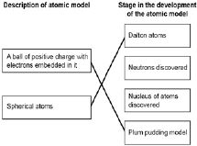
1
1
[8]
Q2.
(a) group 7
1
(b)
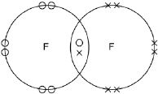
one shared pair anywhere in overlap between two circles or on intersection
6 other electrons on each atom
allow dots or crosses or mixture for all marks
ignore any inner shell electrons
1
1
(c) bromine
1
potassium chloride
1
either order
allow correct chemical formulae
(d) displacement
1
(e) (an) electron
1
(f) smaller than
1
(g) (chlorine has) fewer levels / shells (of electrons)
allow converse for bromine
allow (chlorine has) fewer electrons
allow Cl has 3 levels / shells and Br has 4 levels / shells
ignore atomic number
or mass number
or number of protons
1
mark independent of answer to part (f)
(h) 3
allow multiples
1
(i) there are weak forces
do not accept weak bonds
1
between molecules
1
allow weak intermolecular forces for the first 2 marks
which require little energy to overcome / break
allow does not need much energy to boil
1
[13]
Q3.
(i) two
or 2
1
(ii) magnesium and chloride
either order
not positive / negative
do not credit’chlorine’
accept Mg⁺⁺ and Cl⁻
do not credit just Mg and Cl–
accept cation(s) and anion(s)
1
(iii) 2
1
(iv) electrons
accept charges
1
(v) any three from
• (is a) giant structure/lattice structure
• crystalline / hard
accept just 'crystals(s)’
• high melting point / solid
• high boiling point
• conductor (of electricity) when dissolved in water
or conductor (of electricity) when ions are free to move
• conductor (of electricity) when molten
• soluble in water
3
[7]
Q4.
(a) 408 kg
1
(b) all points correct
± ½ small square
2
allow 1 mark if 5 points correct
best fit line
1
(c) 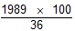
1
5525 dm³
1
(d) relative formula mass of TiCl₄ is 190
1
25.26 %
1
Answer given to 3 significant figures = 25.3 %
1
25.23% with or without working gains 3 marks
(e) argon is unreactive
1
water (vapour) would react with sodium
allow water (vapour) would react with titanium(IV) chloride
1
and air contains oxygen that would react with reactants
allow and air contains oxygen that would react with products
1
(f) (titanium conducts electricity) because electrons in the outer shell of the metal atoms are delocalised
1
and so electrons are free to move
allow the delocalised electrons in the metal carry electrical charge through the metal
1
through the whole structure
1
[15]
Q5.
(a)
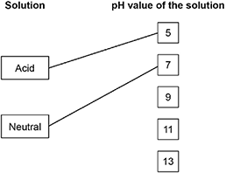
extra lines from solution negate the mark
2
(b) H⁺
1
(c) 3
1
(d) Neutralisation
1
(e) sodium sulfate
1
(f) Add indicator to sodium hydroxide solution
allow add indicator to sulfuric acid
1
Add sulfuric acid (gradually)
allow add sodium hydroxide solution (gradually)
1
allow pH probe
until indicator just changes (colour)
or until universal indicator turns green or shows pH7
1
[9]
Q6.
(a) bromine
1
ions
1
atoms
1
(b) correct scale on y axis
1
points correctly plotted using the scale
± ½ small square
1
best-fit line drawn
1
(c) value for oxygen divided by corresponding time
1
× 60
1
= 0.05 (cm³ / s)
allow 0.05 with no working shown for 3 marks
1
[9]
Q7.
Level 3 (5–6 marks):
A coherent method is described with relevant detail, which demonstrates a broad
understanding of the relevant scientific techniques, procedures and safety precautions. The
steps in the method are logically ordered with the dependent and control variables correctly identified. The method would lead to the production of valid results.
Level 2 (3–4 marks):
The bulk of a method is described with mostly relevant detail, which demonstrates a
reasonable understanding of the relevant scientific techniques, procedures and safety precautions. The method may not be in a completely logical sequence and may be missing
some detail.
Level 1 (1–2 marks):
Simple statements are made which demonstrate some understanding of some of the relevant scientific techniques, procedures and safety precautions. The response may lack a logical structure and would not lead to the production of valid results.
0 marks:
No relevant content
Indicative content
Named chemicals
• copper oxide
• sulfuric acid
• copper sulfate
Correct use of apparatus
• stirring rod
• spatula
• beaker
• filter funnel and filter paper
• evaporating basin
• Bunsen burner
• tripod and gauze
• bench mat
• conical flask
Method
• add (excess) copper oxide to sulfuric acid
• heat the mixture
• filter the mixture
• method to evaporate some of the water from the filtrate eg using a water bath or evaporating to half volume
• leave solution (to cool and) to form crystals
• remove and dry crystals
Safety
• wearing of safety glasses / goggles
• care with use of sulfuric acid as corrosive
• warming not boiling mixture of copper oxide and sulfuric acid
• hold beaker containing warm mixture with tongs whilst filtering
[6]
Q8.
(a) Z
1
(b) magnesium sulfate does not react with any of the metals
allow there is no change / increase in temperature with any of the metals
1
(c) temperature increase
1
(d) Level 2 (3–4 marks):
A detailed and coherent plan covering all the steps. The steps include the improvements and are set out in a logical manner.
Level 1 (1–2 marks):
Simple statements of improvements to the apparatus or steps are made but they may
not be set out in a logical manner.
0 marks:
No relevant content
Indicative content
Simple statements
• stir the solution
• use the same amount of each solution
• use the same concentration of solution
• put insulation or a lid on the beaker
• measure how high temperature goes
Coherent statements in a logical order
• pour a fixed, measured volume of the metal salt solution into a plastic / polystyrene cup
• measure and record the temperature of the solution
• stir and add 1 g of metal to the solution
• (put a lid on the cup)
• measure and record the temperature after a set time or measure and record
the greatest / highest temperature
• calculate and record the temperature increase
• (repeat each individual experiment at least two more times and calculate the mean temperature increase)
4
(e) Activation energy
1
(f) 386 (kJ) / 1370 × 100
1
28 %
1
[10]

