Week 6 – Balanced and Unbalanced Forces

Balanced forces
When two forces acting on an object are equal in size but act in opposite directions, we say that they are balanced forces.
If the forces on an object are balanced (or if there are no forces acting on it), this is what happens:
- a stationary object stays still
- a moving object continues to move at the same speed and in the same direction
Remember that an object can be moving, even if there are no forces acting on it.

Force diagrams
We can show the forces acting on an object using a force diagram. In a force diagram, an arrow represents each force. The arrow shows:
- the size of the force (the longer the arrow, the bigger the force)
- the direction in which the force acts
The arrow should be labelled with the name of the force and its size in newtons. Here are some examples of situations involving balanced forces.
.
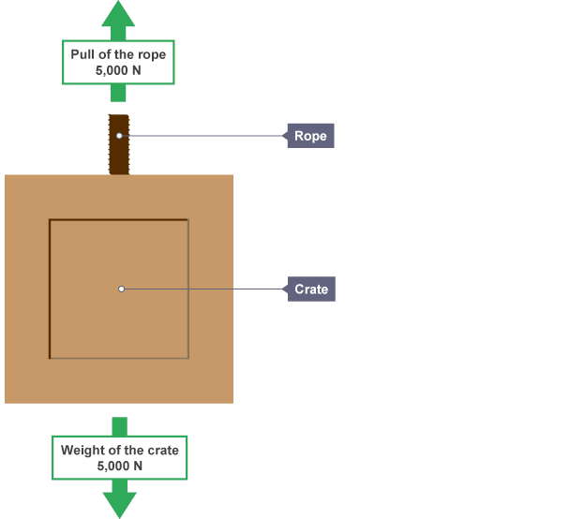

Hanging objects
The forces on this hanging crate are equal in size but act in opposite directions. The weight pulls down and the tension in the rope pulls up

The weight of the crate is balanced by the tension in the rope
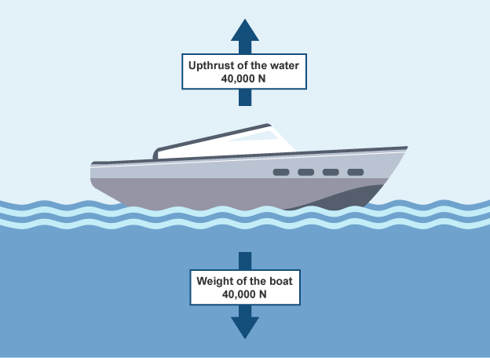

Floating in water
Objects float in water when their weight is balanced by the upthrust from the water. The object will sink until the weight of the water it pushes out of the way is the same as the weight of the object.

The weight of the boat is balanced by the upthrust from the water

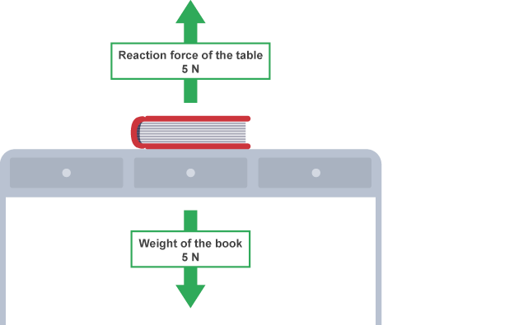

Standing on the ground
When an object rests on a surface such as the ground, the reaction force from the ground balances its weight. The ground pushes up against the object. The reaction force is what you feel in your feet as you stand still. Without this balancing force you would sink into the ground.

The weight of the book is balanced by the reaction force from the table

Unbalanced forces
When two forces acting on an object are not equal in size, we say that they are unbalanced forces. The overall force acting on the object is called the resultant force. If the forces are balanced, the resultant force is zero.

If the forces on an object are unbalanced, this is what happens:
- a stationary object starts to move in the direction of the resultant force
- a moving object changes speed and/or direction in the direction of the resultant force
In the example below, the resultant force is the difference between the two forces:
100 – 60 = 40 N (to the right)
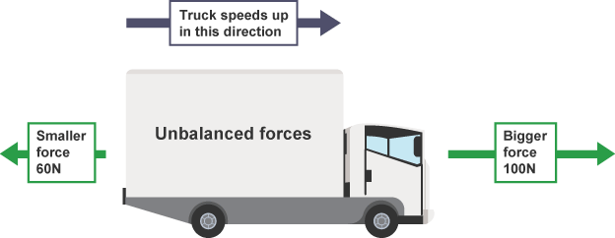

The truck speeds up in the direction of the resultant force

The change in the motion of an object depends upon:
- the size of the resultant force
- the direction of the resultant force
The greater the resultant force, the greater the change in the motion of the object. Whether a moving object speeds up, or slows down, depends on the direction of the resultant force:
- the object speeds up if the resultant force acts in the direction of movement
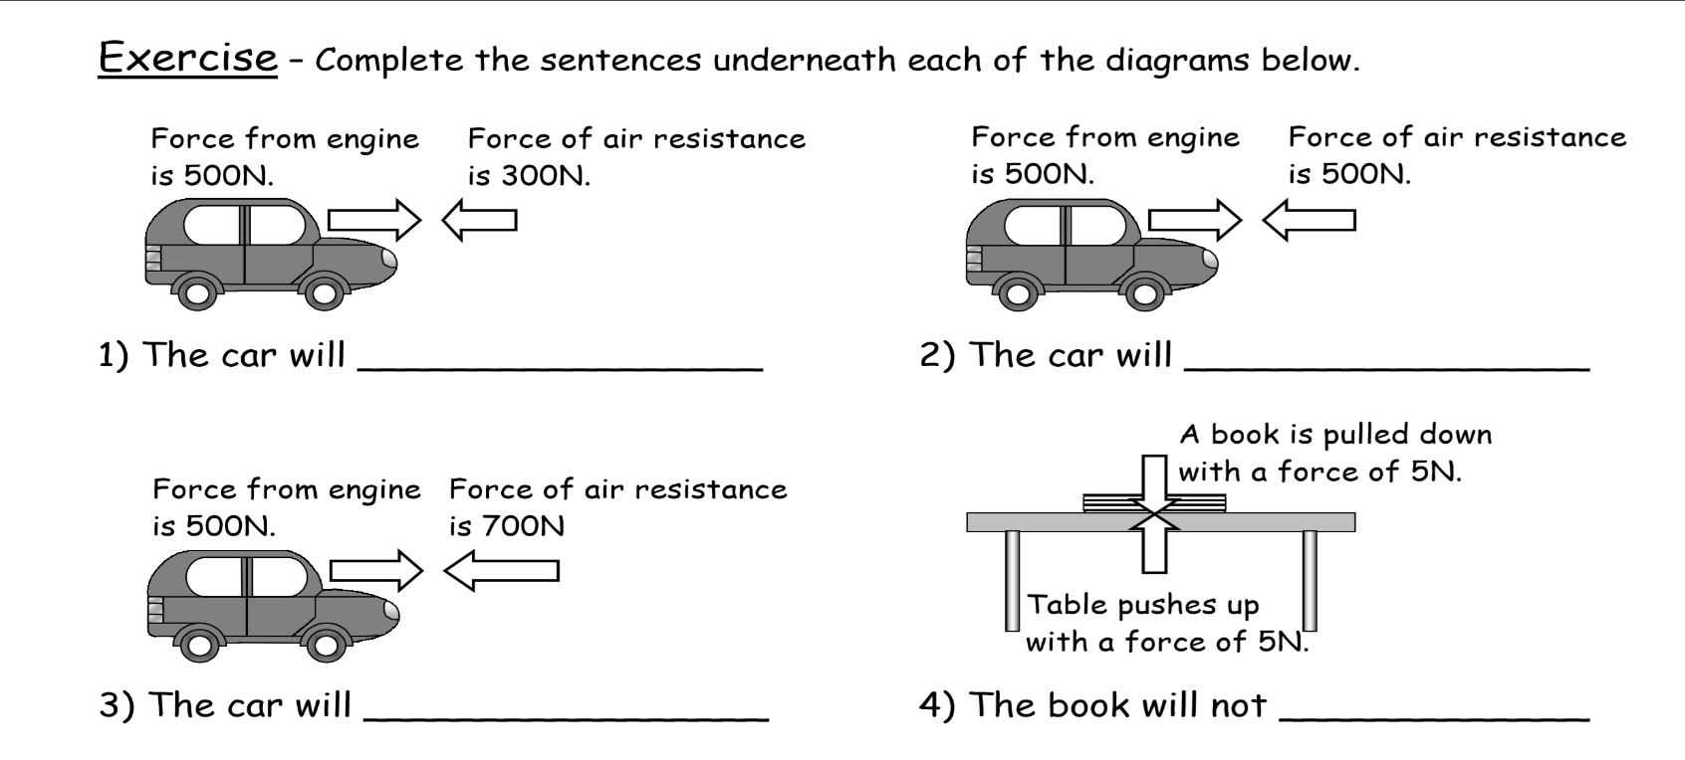
- the object slows down if the resultant force acts opposite to the direction of movement

