Week 7 - Electricity

Circuit symbols
We use circuit symbols to draw diagrams of electrical circuits, with straight lines to show the wires. The diagram shows some common circuit symbols.

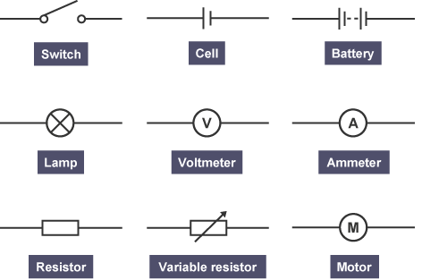

Cells and batteries
The symbol for a battery is made by joining two more symbols for a cell together.

Make sure you know the difference between these two symbols

Circuit Symbols- Look Cover Write Check
- Try to do as much as you can from memory.
- In a different colour, add in the pieces of information or diagrams that you could not remember.
Name | Diagram try 1 | Diagram try 2 | Diagram try 3
Cell
Battery
Voltmeter
Ammeter
Lamp

Resistor
Variable resistor
Motor

