Week 5 - Forces

What are forces?
A force can be a push or a pull. For example, when you push open a door you have to apply a force to the door. You also have to apply a force to pull open a drawer.
You cannot see a force but often you can see what it does. When a force is exerted on an object, it can change the object’s:
- speed
- direction of movement
- shape (for example, an elastic band gets longer if you pull it)
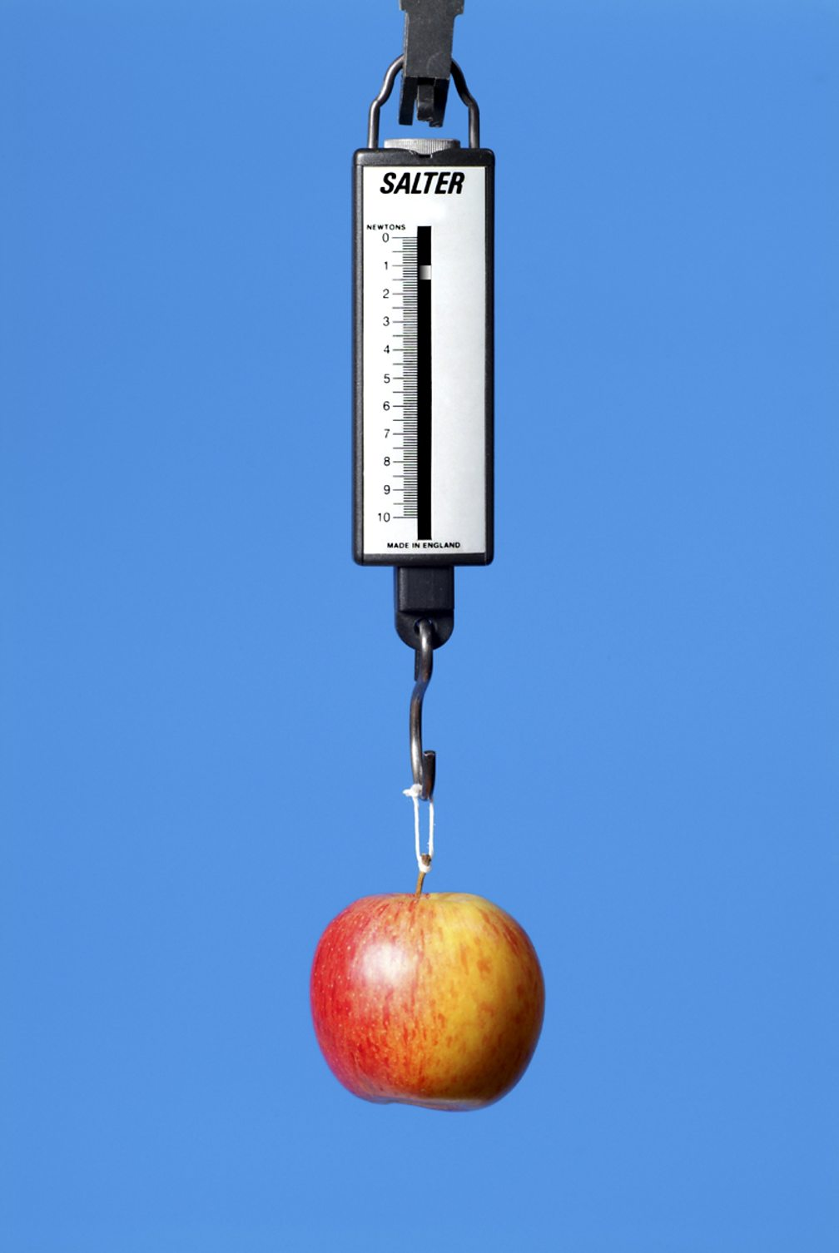
Forces can be contact forces, where objects must touch each other to exert a force. Other forces are non-contact forces, where objects do not have to touch each other. These include:
- gravity
- magnetism
- forces due to static electricity

A force meter, also called a newton meter, is used to measure forces

Measuring forces
Forces can be measured using a force meter, also called a newton meter. Force meters contain a spring connected to a metal hook. The spring stretches when a force is applied to the hook. The bigger the force applied, the longer the spring stretches and the bigger the reading.
The unit of force is called the newton, and it has the symbol N. The greater the force, the bigger the number, so 100 N is a greater force than 5 N.

Exercise
What three things can a force do to an object?
- ________________________________________
- ________________________________________
- ________________________________________
Give three examples of forces
- ________________________________________
- ________________________________________
- ________________________________________
What is used to measure force?
________________________________________
What is the unit of force?
________________________________________

