**Week 2 - Energy Transfer Diagrams**

Energy transfer diagrams show the locations of **energy stores** and **energy transfers**. For example, consider the energy transfers in the simple electrical circuit below.

We can show the transfers like this:

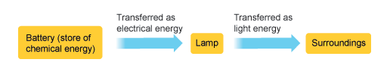

The battery is a **store** of chemical energy. The energy is **transferred** by electricity to the lamp, which **transfers** the energy to the surroundings by light. These are the **useful** energy transfers - we use electric lamps to light up our rooms.

But there are also energy transfers that are not useful to us. In the example above, the lamp also transfers energy to the surroundings by **heating**. If we include this energy transfer, the diagram looks like this:

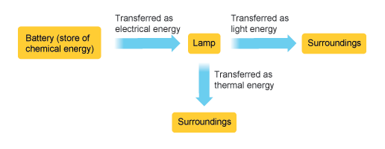

**Changes in energy**

Energy is always changing from one form into another. The Diagram below shows the energy changes in a torch

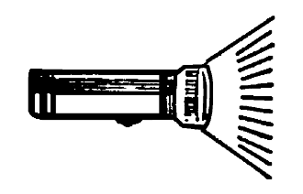

Chemical ------🡪 Electrical ------🡪 Heat + Light

|  |  |
| --- | --- |
| Device | Energy Transfer |
| j0199283 | An electric toaster transfers \_\_\_\_\_\_\_\_\_\_\_ energy to \_\_\_\_\_ energy, \_\_\_\_\_\_ energy, \_\_\_\_\_\_\_\_\_ energy and \_\_\_\_\_\_\_\_\_\_\_\_\_\_\_ \_\_\_\_\_\_\_\_\_\_\_\_ energy. |
| MCj03839960000[1] | A light bulb transfers \_\_\_\_\_\_\_\_\_\_\_\_ energy to \_\_\_\_\_\_\_ energy and \_\_\_\_\_\_\_\_\_ energy. |
| MCj03309820000[1] | Speakers transfer \_\_\_\_\_\_\_\_\_\_ energy to \_\_\_\_\_\_\_ energy. |
| MCj04126320000[1] | A hair dryer transfers \_\_\_\_\_\_\_\_\_\_\_ energy to \_\_\_\_\_\_\_ energy, \_\_\_\_\_\_\_ energy and \_\_\_\_\_\_\_\_\_\_ energy |
| MCj03111020000[1] | A microwave oven transfers \_\_\_\_\_\_\_\_\_\_ energy to \_\_\_\_\_\_\_\_\_\_\_ energy, \_\_\_\_\_\_\_ energy and \_\_\_\_\_\_\_\_\_ energy. |
| MCHH01164_0000[1] | A vacuum cleaner transfers \_\_\_\_\_\_\_\_\_\_\_\_ energy to \_\_\_\_\_\_\_\_\_ energy, \_\_\_\_\_\_\_ energy and \_\_\_\_\_\_\_\_ energy |

