Year 11 October half-term work
Verbs in red are irregular
Remember that you can check the answers online if you go to Spanishdict.com
- Verb triangles/hands. Spend 5 minutes each day conjugating these verbs
Lunes
Apagar (yo)
Reciclar (tú)
Reducir (nosotros)
Martes
Ahorrar (él/ella)
Salir (yo)
Hacer (yo)
Miércoles
Ir (nosotros)
Reciclar (tú)
Salir (ellos/ellas)
Jueves
Hacer (yo)
Reducir (tú)
Estudiar (nosotros)
Viernes
Jugar (yo)
Aprobar (tú)
Salir (yo)
Sábado
Chatear (yo)
Navegar (nosotros)
Ir (yo)
Domingo
Ver (tú)
Evitar (yo)
Chatear (nosotros)

I turn off, I turned off, I am going to turn off
You recycle, You recycled, You are going to recycle
We reduce, We reduced, We are going to reduce
He/she saves, She saved, She is going to save
I go out, I went out, I am going to go out
I do, I did, I am going to do

We go, We went, We are going to go
You recycle, You recycled, You are going to recycle
They go out, They went out, They are going to go out
I do, I did, I am going to do
You reduce, You reduced, You are going to reduce
We study, We studied, We are going to study
I play, I played, I am going to play
You pass, You passed, you are going to pass
I go out, I went out, I am going to go out

I chat, I chatted, I am going to go out
We surf, We surfed, We are going to surf
I go, I went, I am going to go
You watch, You watched, You are going to watch
I avoid, I avoided, I am going to avoid
We chat, We chatted, We are going to chat

2a. Foundation:
Write four ACTION sentences using these words:
- El fútbol
- Los bolos
- Una película
- El Rey Richard III

2b. Higher:
KILTTS essay plan for this question:

Las ventajas de la tecnología | Las desventajas de la tecnología
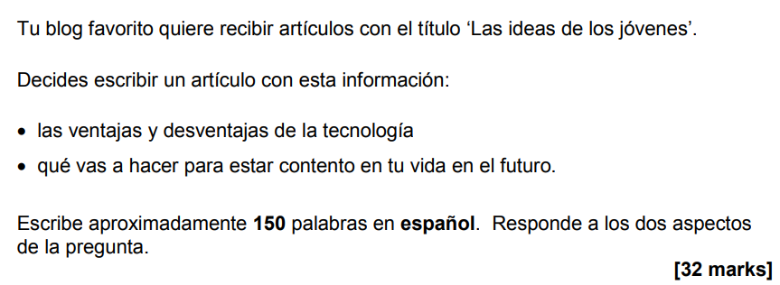

El cine

La Felicidad
Happiness

Key words and Ideas – table and spider diagram
Link – organise your ideas into three themes. Choose one colour for each theme and highlight the words/ideas
Eg. theme 1 = hobbies, theme 2 = family and friends, theme 3 = technology
Tenses – choose verbs that relate to the topics you are planning to discuss and practice your 5-a-day with the yo and nostoros subjects



Tone – circle formal or informal
Structure – into 3 or more paragraphs of 50 words each (approx. 4 ACTION sentences) - we will write this up together during P6 intervention next month so ignore this point for now.

